Modelling Extreme Values with reference to River Flooding

By

Linda Kozlowska

October 2004

A dissertation submitted for the award of the degree of Master of Science
in
Actuarial Science

Faculty of Actuarial Science and Statistics

Cass Business School
City University, London

Supervisor: Dr Linda Wolstenholme

I would like to thank Dr Linda Wolstenholme for her advice and supervision during the course of this dissertation.

Special thanks to my parents Leszek and Barbara for all the support and encouragement over all these years.

Abstract

In autumn 2000 exceptional rainfall levels caused widespread flooding in about 700 locations across England and Wales. Approximately 1.4 million people in Britain are at risk of flooding. August 2004 was recorded as the wettest for 50 years with rainfall 77% above average. That same month Boscastle in Cornwell suffered serious damage when a 3 metre wave swept in from the sea. These statistics highlight the seriousness of flood risk in Britain today and provided the subject for this dissertation.

Naturally flooding can be prevented using physical measures such as barriers and dams but the aim of this dissertation is to discover whether one can predict the occurrence and intensity of future floods. As a result Extreme Value Theory was chosen to model river flows of the River Teifi in Wales. A relatively new statistical discipline, Extreme Value Theory, provides a way to model random variables and stochastic processes at unusually high or low levels.

During the research for the dissertation it became clear that, despite the damage floods cause, flood insurance is not widespread. Reasons for this were discussed and possible solutions looked into. There are also concerns that flood risk is increasing as a result of which more homes will become uninsurable or premiums will increase so much that they will be unaffordable for many people. Using Extreme Value Theory it was possible to show that flood risk has increased over the last 40 years and the ability to calculate this increase can help establish premiums that reflect flood risk more accurately.

Contents

Acknowledgements

Abstract

- Introduction 1

- Flooding 3
  - Flooding: Causes and Prevention …………………………………….. 3
    - Causes ………………………………………………………… 3
    - Prevention …………………………………………………….. 4
  - Flooding in the UK …………………………………………………… 5
    - Flood Risk ……………………………………………………. 6
    - Flood Insurance ………………………………………………. 9
    - Costs to the Insurance Industry ………………………………. 10
    - Continuing Flood Insurance in the Future …………………… 11

- Extreme Value Theory 14
  - Basic Concepts ……………………………………………………….. 14
  - Classical Extreme Value Models …………………………………….. 15
  - Block Maxima ………………………………………………………... 17
    - Modelling Block Maxima ……………………………………. 17
    - Parameter Estimation ………………………………………… 18
    - Return Levels ………………………………………………… 19
    - Model Checking ……………………………………………… 20
  - The r Largest Order Statistic Model …………………………………. 21
    - Modelling the r Largest Order Statistics. …………………….. 21
    - Parameter Estimation ………………………………………… 23
    - Model Checking ……………………………………………… 23
  - Threshold Models ……………………………………………………. 24
    - The Generalised Pareto Distribution …………………………. 24
    - Modelling Threshold Exceedances …………………………… 25
    - Threshold Choice …………………………………………….. 25
    - Parameter Estimation ………………………………………… 27
    - Return Levels ………………………………………………… 28
    - Model Checking ……………………………………………… 29

- Data Analysis 30
  - Annual Maxima ……………………………………………………… 30
  - The r Largest Order Statistic Model …………………………………. 36
  - Exceedances over a Threshold ……………………………………….. 40

- Further Analysis 45

- Conclusion 52
  - Final Comments ……………………………………………………… 52
  - Conclusion …………………………………………………………… 56

References 59

Bibliography 61

Appendix A: Derivation of log-likelihood for the GEV distribution and GPD 63

Appendix B: Data Analysis using the Extremes Toolkit 65

Chapter 1: Introduction

Flooding is the most common environmental hazard accounting for about one third of natural catastrophes. It is also the most damaging of all natural disasters including earthquakes and drought. Between 1973 and 1997 an average of 66 million people a year suffered flood damage. In 1998 the death toll from flooding hit almost 30,000 (Nagle, 2003). According to official estimates 1.4 million people in Britain are at risk of flooding.

Flooding takes many forms including river flooding, overwhelmed drainage systems, storm surges destroying coastal dikes and the inundation of coastal areas by high waves. However despite this, insurance cover against flood risk is not widespread; Nagle (2003) writes, floods have less than a 10% share in insured losses. One of the main reasons for this is due to the unpredictable nature of flooding. The floods in Boscastle, Cornwall, in August 2004 for example were described as “a freak deluge”. Secondly, insurance is not always available to property owners and, if it is, may be unaffordable. Chapter 2 will consider the main causes, effects and physical methods to prevent flooding. Following this, issues facing British insurers will be looked at together with factors influencing their ability to provide affordable cover.

This leads to the question of whether flood events can be modelled. Clearly if one could predict the likelihood of floods occurring in a chosen area, calculating the risk more accurately may lead to more affordable cover. Current practice is based on postcodes and property owners can be charged the same premium regardless of whether they are inside or outside a floodplain. Additionally the ability to forecast maximum flood heights could help in the development of better defences.

Extreme Value Theory (EVT) can provide the solution. EVT originated in the 20th century. It is a unique statistical discipline providing a way to “predict the unpredictable” (Matthews (1996), cited in Embrechts, Klüppelberg and Mikosch (1997)). The aim of EVT is to quantify the behaviour of sequences of random variables and stochastic processes at unusually high or low levels.

EVT was primarily used in civil engineering, for example checking the ability of structures to withstand forces that may impact on them. With the help of EVT it was possible to estimate anticipated forces using historical data, an obvious example being a sea wall’s ability to withstand exceptionally strong waves.

Nature can be seen as an unpredictable phenomenon and for this reason EVT is very useful in modelling and predicting events such as flooding, temperature, rainfall, even pollution. Today however the theory has been extended and is used beyond environmental data. It can be applied to other industries such as insurance (portfolio adjustment), finance (risk assessment) and telecommunications (traffic prediction).

Classical distributions will be looked at including the Fréchet, Weibull and Gumbel and a combination of the three families into the Generalised Extreme Value (GEV) distribution. This is followed by a discussion of three models for analysing extremes: block maxima, r largest order statistic model and exceedances over a threshold. For each of these the modelling process, techniques for parameter estimation and model checking are discussed. The modelling of extreme values will be illustrated with flow data for the River Teifi, in Wales.

Chapter 2: Flooding

2.1 Flooding: causes and prevention
2.1.1 Causes
River flooding occurs when there is too much water in a river’s channel as a result of which the water breaks through the river bank and spreads over the surrounding land.
Flooding is primarily a result of external climatic forces whereas secondary flood intensifying conditions tend to be basin specific. Human interference has intensified many floods, for example a greater number of people living in the floodplain has inevitably led to increased flood damage.

One of the main natural causes of flooding is rain and when there is too much extra water it will inevitably break over the river bank. The melting of snow and ice often leads to flooding in the spring, particularly in countries where the land is flat with high mountains. In Canada, for instance, the melting of snow in springtime is followed by high flows of the northern rivers compared to much lower level flows in the winter. Other natural disasters such as hurricanes, cyclones, typhoons and earthquakes are all known causes of flooding.

The atmosphere has been changing significantly since the last century. The build up of atmospheric gases is leading to global warming which in turn leads to melting of polar icecaps. As a result we would expect flooding to increase particularly in coastal regions (Levine (1990), cited in Hipel and McLeod (1994)).

Failure of structures designed to protect against flooding also contributes to greater flood risk. If a dam does not have enough holes in times of heavy rain, water builds up in the reservoir and may eventually spill over the top of the dam.

Environmental changes are also responsible for flooding and its increase. Deforestation and clearance of vegetation reduces an area’s flood retention capacities. Often the run off is very muddy leading to extensive damage.

2.1.2 Prevention
Flooding can have catastrophic effects, be they physical, financial or economic and for this reason ways to prevent or minimise the damage have been sought. Nagle (2003) describes three stages in flood prevention, as outlined below.

1930s to 1960s: The Structural Era
Traditionally floods have been managed by methods of ‘hard engineering’ and some of these are described below.
Levees, constructed from concrete, make banks higher so that any excess water in a river does not overflow. Another popular measure are flood walls built by the river bank to protect towns. Dams can be used to control floods: during heavy rainfall holes can be opened in the dam thus allowing water to flow quicker and not build up. Floodways are artificial river channels built to divert the extra flow of water in rivers. During heavy rainfall, river water flows through two channels which reduces the chance of flooding. Flood barriers such as the “Thames Flood Barrier” are walls similar to dams. Flood barriers are usually built near the mouth of a river and protect against floods caused by high tides or strong winds. The Thames Barrier was designed to protect Greater London from a ‘once-in-a-millennium’ storm surge. The flood gate is closed to keep water out of the river but left open when the weather is calm.

However, despite the above methods being used as ways to reduce floods in some locations they may lead to unexpected effects elsewhere in the drainage basin, an example being the Mississippi River, USA (Nagle, 2003). For this reason despite being built with the best intentions these defence structures can sometimes intensify flooding.

1960s to 1980s: The Unified Floodplain Management Era
This era in flood prevention included the development of flood warnings, land use planning and insurance.
During the 1970s flood forecasting became more accurate and is still widely used today. Weather satellites and radars are used to predict flooding and developed countries have seen economic losses reduced by up to 40% thanks to flood warnings and forecasts. Land use planning is a means of protecting new housing developments. In England and Wales this is controlled by the Town and Country Planning Acts.
Although insurance does not physically prevent damage to properties they can be protected by providing money for repairs and replacement.

1980s to present: The Post-Flood Hazard Mitigation Era
Measures include property acquisition and land use control.
Physical defence methods include adjustments to buildings. People are encouraged to improve the resistance of their property to flood damage and the Association of British Insurers (ABI), and the Environment Agency (EA) amongst others, have issued guidelines on how to do so. In the short term properties can be protected with sandbags, shields to seal windows and doors and damageable goods can be moved to higher levels. Long term measures include building properties on stilts, as illustrated in figure 2.1.

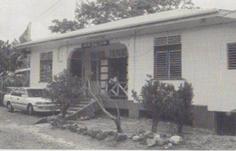
Figure 2.1 Caribbean Police Station on stilts (source: Nagle, 2003)

The EA is testing a £3 million flood defence system which proved very successful in Europe (Nagle, 2003). People living in flood risk areas can listen to local radio stations or ring the Environment Agency Floodline for up to date bulletins regarding flooding. The Social Fund can provide emergency financial help.

2.2 Flooding in the UK
In the UK, flooding is associated with deep depressions (low-pressure systems) in autumn and winter which are both long in duration and wide in area coverage. The floods in winter 2000-1 and 2002-3 being good examples of this (Nagle, 2003). Areas under particular risk include Herefordshire, East Sussex, Thames Valley, York, Colchester, Bristol and Glasgow. The first part of this section looks at flood risk in the UK; factors contributing to its increase and possible solutions. This is followed by a look at the insurance industry in the UK together with suggestions on how to maintain affordable flood insurance in the future.

2.2.1 Flood risk
In autumn 2000 unprecedented rainfall levels caused widespread flooding in about 700 locations across England and Wales. This demonstrated the serious consequences which flooding can have for people and their property. Around 10,000 properties were damaged and 37,000 in another 17 locations were saved by sandbags alone. The total bill to insurers including associated storm damage was £1.3 billion (£860million domestic, £440m commercial property) (ABI, November 2001).

Flood risk in the UK is increasing. According to the Government’s chief scientific adviser, Sir David King, the number of people at high risk of flooding could double to 3.5 million by 2080 (BBC News 19/02/04). Figure 2.2 shows the possible best and worst case scenarios for flooding risk to Britain by the 2080s. The map was printed in a paper outlining the government’s 20 year strategy to tackle the growing problems of flooding and coastal erosion in England. The report also predicted that Yorkshire, Lancashire, Lincolnshire and the South West would probably be worst affected by future floods.

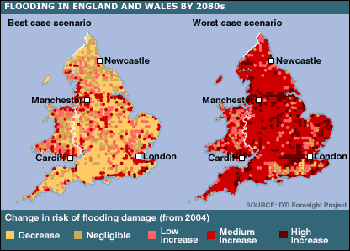
Figure 2.2 flooding in England and Wales by the 2080s (source: BBC News website)
Some of the main factors contributing to an increase in flood risk are given below.
Growing demand for housing:
Demand for housing is increasing, particularly in London, the South East and East Anglia. More often Brownfield sites are chosen over Greenfield sites to meet this demand despite being often located within the floodplain. Currently around 10% of homes in England and Wales are in high risk areas and not adequately protected; the use of Brownfield sites will inevitably increase this figure. The ABI has stated in numerous reports that development in flood risk areas must be curtailed unless developers are willing to invest in all necessary defences and no safer location is available. In July 2003 the ABI suggested that when choosing housing sites local planning authorities should consider:
- Liability of area to flooding;
- Probability of flooding occurring both now and over time;
- The extent and standard of existing flood defences and effectiveness over time;
- The likely depth of flooding;
- The rates of flow likely to be involved;
- The likelihood of impact on other areas, property and inhabitants;
- Effects of climate change;
- The extent to which the development proposed is designed to deal with flood risk.

Poor flood defence:
Following the autumn 2000 floods, the government said all damaged flood defences had been reinstated although in many locations defences returned to their pre-existing levels and had not been enhanced. The Department for Environment, Food and Rural Affairs (DEFRA), on the other hand, felt that many flood defences were below their standards of service for densely populated areas.

A related problem is that funding for flood defence is determined by the local authority’s budget size and local priorities/commitments. However a flood is not limited by political boundaries. Hence, although a region may be protected, the neighbouring area may not be. In the future, new EU requirements should produce a more integrated approach to river basin plans. This should improve the current situation where it is often unclear who is responsible for floods – the Environment Agency or Local Council.

The Government also needs to make a greater investment in flood defences. The impact of climate change needs to be taken into account when designing these defences. If flood defences are improved to ‘reasonable’ levels of protection then the insurance market can function more effectively. Better protected areas will allow insurers to provide insurance that both meets people’s needs and is affordable. Currently the annual funding of the Government’s flood defence programme stands at a record £478 million and is expected to increase to £564 million in the next three years. (BBC News 29/7/04). Figures from The Economist (28/08/04) state that this could rise to £1.1 billion over the next 20 years. Figure 2.3 shows the increase in Government spending on flood defences between 1990 and 2003.

Figure 2.3 Government spending on flood defences (source: ABI)

Flooding is not only riverine, heavy rainfall and poor drainage systems often contribute. ABI research shows a significant proportion of flood insurance claims are non-riverine. In 2002, despite being outside the floodplain, hundreds of houses were flooded in Glasgow and Inverness due to intense rainfall overwhelming the drainage system. Therefore when considering improving defences, drainage solutions must also be looked at.

Climate and Environmental changes:
Heavier and more frequent rainfall levels are one contributor to increased flood risk. The Environment Agency expects climate change to increase average rainfall by around 20% by the 2080s. The Operations Director for the National Flood Forum, Gill Holland, is quoted as saying: “The wetter weathers that are predicted as a result of climate change may double the frequency of floods within the next 50 years” (The Times 03/03/04).

Coastal areas are also under threat as sea levels are rising by 4-7mm each year as the sea becomes warmer. More severe coastal storms are predicted which can raise sea levels by as much as 3 to 5 metres. Additionally, mean wave heights are increasing.

2.2.2 Flood insurance
Insurance enables householders and businesses to minimise the cost of the damage arising from flooding. Insurance can be offered where the peril is occasional; affects a limited proportion of the population at any one time, and the cost can be predicted, and adequately covered by premiums paid, over a period. Naturally, the higher the risk of flooding, the higher the premium.

In many countries the government compensates flood victims. Flood insurance was not a standard feature of household insurance policies but was introduced in the UK in 1961. The insurance industry guaranteed all household insurance policies would include flood cover “no matter what the risk” while the government committed to providing flood defences in areas at high risk of coastal or river flooding. Both insurers and the Government agreed that cover would be withheld in “exceptional circumstances where continual, regular flooding was unavoidable…or apply especially loaded terms to reflect higher risk”. One criticism of this is that the government was able to cut spending on flood defences because there was less political pressure to build them (David Crichton, independent environmental consultant, The Economist, 15/11/01).

Following the extreme flooding events of autumn 2000, insurance companies agreed to maintain flood cover for existing households and small businesses for 2 years (1st January 2001 until 31st December 2002). This was because the government was unable to immediately repair or replace any defences that had been damaged and many people would have been left with neither physical nor financial protection. There were however circumstances under which cover could be discontinued:
- Residents of flood risk area have refused flood alleviation scheme on grounds of amenity;
- New properties have been built in a floodplain area without defences;
- The flood risk has increased to the extent where flooding is inevitable and there is no prospect of a flood defence scheme being implemented within a reasonable timescale.

The agreement did not cover premium rates since these must reflect local conditions. The ABI reported in 2001 that the scheme was working well with only a handful of cases where policyholders experienced difficulty renewing cover. The insurance industry also gave the government a deadline of January 2003 to increase spending on flood defences and to produce a map outlining areas most at risk. Progress has been made and as figure 2.3 showed spending has significantly increased since 2000. Section 2.2.4 will discuss the development of flood risk maps.

The Department of Trade and Industry’s Foresight flood defence project has taken an interesting step in helping develop flood defences. “FloodRanger” is a computer game set in a fictional region over 100 years. Planners and engineers can use it to work out strategies to cope with real-life flooding. The game consists of various climate scenarios and locations and it is up to the player to use an allocated budget to provide optimum flood protection (BBC News, 19/02/04).

2.2.3 Costs to the insurance industry
The ABI reports that between 1990 and 2002 weather related (flood and storm) damage insurance claims have cost an average of £825 million per annum in the UK. After the floods of autumn 2000 insurers paid out more than £1 billion. These enormous amounts have led to fears that the price of insurance in high risk areas will be beyond the reach of many property inhabitants.

Insurers have been concerned with the potential costs of floods for some time and have researched possible impacts. It is believed that the true cost of insuring against flood risk is considerably higher than stated for reasons including:
- Not all properties are insured: around 25% of households choose not to insure their contents;
- Insured properties may be underinsured (informal survey in Lewes suggested 15% of residents were underinsured by between £5000-£20,000);
- Costs of emergency measures and repairs to infrastructure fall to the Government (DTLR paid out £3.8 m to local authorities in 2000);
- Hidden costs such as higher healthcare costs, days lost at work due to sickness and the need to deal with effects of flooding. Studies show respiratory, skin problems, depression and other mental health problems increase significantly in the period following a flood. A recent study, in Lewes, showed that people whose homes were flooded were four times more likely to suffer psychological distress than average.

2.2.4 Continuing flood insurance in the future
For the reasons discussed, there are concerns that flood risk is becoming uninsurable. A large concern is development in high risk areas. Additionally areas outside the floodplain require proper provision and maintenance of the drainage systems. Climate change is being looked at more frequently as it affects all households regardless of whether they are inside or outside the floodplain. A recent government study argues that cutting down emissions of greenhouse gases will decrease the risk of flooding (BBC News 22/04/04). This section focuses on solutions proposed for flood insurance to remain a means of protection for homeowners.

Below are some of the factors that determine the sustainability of insuring properties in the floodplains:
Risk: partially defined by the probability of a flood event happening and is sometimes expressed as the return level.
Aggregation: flooding affects all properties in an area (for example vehicle damage) and insurers are unable to spread risk adequately across a portfolio where large aggregation occurs. In such cases insurers must either seek reinsurance treaties or limit exposure by refusing to write more than a limited proportion of business in the area.
Value: the value of assets such as residential and commercial property is relatively straightforward to assess. The cost of business interruption is also covered by insurers.
Vulnerability: modern housing is more vulnerable due to greater use of chipboard floors, dry wall plasterboard and cavity insulation. Additionally contents claims tend to be greater as people tend to own better and more expensive equipment, for example computers, LCD televisions and DVD players.
Willingness/ability: of policyholders to pay the full premium required to restore damage or share the risk and bear a portion of the cost themselves. This is driven by a combination of affordability and perception of risk.

The ABI feels that in order for insurers to provide affordable cover the minimum flood defence protection level should be at least 0.5% (1 in 200 year return period) up to the year 2050, after taking climate change into consideration. However insurance may be provided at lower standards but with the extra risk being reflected in the premium.

A solution has also been proposed for locations that are not suitable for flood alleviation measures due to technical or economical reasons. Insurers are working with the Government and others to identify measures that might enable some flood insurance cover or which would enable householders to manage the risk more effectively themselves. Householders could for example replace existing suspended floors with a new solid concrete floor with damp-proof membranes providing an effective seal against water. The ABI estimates that the use of flood resistant materials could save people between £12,000 and £15,000 on repairs, based on a three bedroom semi detached house (BBC News, 29/07/04).

There are a number of properties that will never have cover available. These are properties that are flooded frequently and there is little or no prospect of flood defences. Unfortunately further developments in the floodplain or significant climate change may lead to many more properties becoming uninsurable in the future.

Recently, the insurance industry has witnessed the development of digital maps that are able to pinpoint individual properties at risk of flooding. The maps are able to tell whether a property is on a hill or raised ground and how flood waters will flow. More Th>n and Norwich Union have begun using maps that are able to identify homes in high risk areas that are less or more prone to flooding. Presently premiums are based on a person’s location or more specifically their post code. Hence properties near floodplains, despite being less likely to suffer significant damage during a flood, are classed under the same risk as those within or closer to the floodplain. Additionally, current code of practice means that insurers are not obliged to offer cover to people living in flood risk areas without adequate defences and none planned for the next three years. If successful, digital maps would enable insurance companies to set premiums based on an individual’s address. Norwich Union estimates that more than 600,000 homeowners who have been refused cover would now be able to apply (The Times, 03/03/04). The main concern with digital maps is that insurance costs could decrease “…for thousands of homeowners in subsidence-prone areas, while leaving others with homes that are virtually uninsurable” (The Sunday Telegraph, 25/04/04). Another worry is that while one house could be refused cover another next door could be approved. The EA has a similar version of the map available to the public from September 2004.

Chapter 3: Extreme Value Theory

3.1 Basic concepts
Extreme value analysis aims to quantify the behaviour of a process at extremely high or low levels. From there one can try to estimate the probabilities of events occurring at levels more extreme than already witnessed. It is possible, for example, to predict return levels such as the height of a river that will be exceeded with probability 1/100 in a given year. Another possibility is estimating the probability that last year’s highest rainfall level is exceeded this year.

Daily rainfall could be denoted by X₁, X₂,… where X₁, X₂,… is a sequence of independent, identically distributed (iid) random variables. The maximum level over an n observation period would be denoted by (where n could be 30 days):

M_{n} = max { X₁, X₂, …, X_{n}}

If the exact statistical behaviour of the X_{i} is known one could formulate the behaviour of the corresponding M_{n}.

In practice the behaviour of the X_{i} is unknown and hence it is difficult to model M_{n}. For this reason a number of assumptions need to be made regarding the behaviour of M_{n}. Letting n → ∞ leads to a family of models that can be calibrated by the observed values of M_{n}. Cole (2001) names this the “extreme value paradigm” since model extrapolation is based on the implementation of mathematical limits as finite level approximations. Despite criticism that the method assumes that the underlying stochastic mechanism of the process being modelled is sufficiently smooth to enable extrapolation to unobserved levels, no alternative has been proposed to date (Cole, 2001).

As with all statistical models, Extreme Value Theory (EVT) does have its limitations. Firstly models are developed using asymptotic arguments and for this reason care is needed in treating them as exact results for finite samples. Secondly models derived under idealized circumstances may not be exact or even reasonable when applied to the process being studied. Finally extreme value models may lead to information being wasted. This results from EVT often making use of only observed extremes in a given period. Returning to the monthly rainfall example one may omit a level for one month despite it being greater than last month’s level because it is not the maximum in that month.

3.2 Classical Extreme Value Models
In order to show the development of classical extreme value models this section will focus on the behaviour of M_{n} = max { X₁, X₂, …, X_{n}}. The distribution of M_{n} can be derived as follows:

Pr {M_{n} ≤ z}
= Pr { X₁ ≤ z, …X_{n} ≤ z }
= Pr { X₁ ≤ z }×…× Pr{ X_{n} ≤ z }
= { F (z) }^{n} where F is the distribution function for random variable X.

However, the distribution is unknown but one could either estimate F from the observed data using standard statistical techniques or accept F as unknown and look for families of models for F^{n} which can be estimated on the basis of extreme data. Looking at the behaviour of F^{n}, for any z < z₊, F^{n} (z) → 0 as n → ∞ so that M_{n} degenerates to a point mass on z_{+.} In order to avoid this difficulty M_{n} can be normalized by finding appropriate constants a_{n} > 0 and b_{n} such that:

M_{n}* = $\frac{M_{n}−b_{n}}{a_{n}}≤z$

$$\text{Pr}\left(\frac{M_{n}−b_{n}}{a_{n}}≤z\right)=$$

= F (a_{n} z +b_{n})

→ G (z) as n → ∞ (3.1)

If G is a non-degenerate distribution function then it must be one of the following three families (known as the Extreme Value Distributions):

- Gumbel: G (z) = $\text{exp}\left\{−\text{exp}\left[−\left(\frac{z−b}{a}\right)\right]\right\}$ - ∞ < z < ∞
- Fréchet: G (z) = $\begin{aligned}\left\{0, z≤b | \right.\end{aligned}$
- Weibull: G (z) = $\begin{aligned}\left\{\text{exp}\left\{−\left[−{\left(\frac{z−b}{a}\right)}^{α}\right]\right\} z<b,a>0,α>0 | \right.\end{aligned}$

Here b is the location parameter, a the scale parameter and α the shape parameter. The three families give different representations of extreme value behaviour corresponding to the different forms of tail behaviour. For example at the upper end tail Fréchet and Gumbel are infinite while Weibull is finite. Figure 3.1 illustrates the densities for the above three distributions with α = 1 and b = 0.
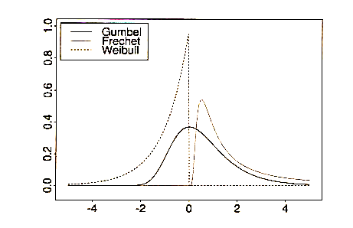
Figure 3.1 Densities of the Gumbel, Fréchet and Weibull distributions (source: Embrechts, Klüppelberg and Mikosch, 1997)

Early applications of extremes saw the adoption of one of these families to the data followed by estimation of the relevant parameters. This approach has two main disadvantages: firstly a method is required by which to select the optimum family and it may be uncertain whether a choice is the right one. Secondly once a model has been chosen any resulting analysis may be biased because one may distort observed values in order to fit the model.

Cole (2001) writes that a statistical implementation is greatly simplified by combining the three models into a single family with the following distribution function:

G (z) = $\text{exp}\left\{−{\left[1+ξ\left(\frac{z−μ}{σ}\right)\right]}^{−1ξ}\right\}$ (3.2)

This is known as the Generalised Extreme Value (GEV) family of distributions with three parameters: μ the location parameter, σ the scale parameter and ξ the shape parameter.
Different values of ξ lead to the three extreme value distributions as follows:
- ξ > 0 corresponds to a Fréchet distribution;
- ξ < 0 corresponds to a Weibull distribution;
- ξ → 0 corresponds to a Gumbel distribution.
Such unification greatly simplifies statistical implementation by removing the uncertainty involved in making prior judgement as to which family to adopt. Instead the inference of ξ determines the most appropriate type of tail behaviour.

3.3 Block Maxima

3.3.1 Modelling Block Maxima

This section outlines how one may use the GEV to model the distribution of block maxima. To start, data is blocked into sequences of length n from which a series of block maxima, M_{n,1} ,…, M_{n,m} , can be generated. Label these block maxima Z₁,…, Z_{m} and if the X_{i} are independent then the Z_{i} are also independent, although even if X_{i} are dependent the Z_{i} may still be independent, see below. The GEV can then be fitted to the set of block maxima.

The choice of block size is critical, amounting to a trade off between bias and variance. An n that is too small leads to bias in estimation and extrapolation; too large gives rise to few maxima leading to a large variance. It is usual to take 1 year and as Smith (2003) writes: “the most convenient time period particularly for environmental processes”. Additionally by using annual maxima for river flows one can avoid dependence. Daily maxima could not be seen as independent however annual or even monthly maxima can be treated as independent random variables. For example the rainfall level on 1st June is independent of the level on 25th May.

3.3.2 Parameter Estimation
Having selected the annual maxima the next step is parameter estimation. Some means of doing this are given below:
- graphical techniques;
- method of moments;
- maximum likelihood estimation;
- Bayesian techniques.

Using maximum likelihood estimation can prove difficult in practice as regularity conditions required for the asymptotic properties, associated with the maximum likelihood estimator, to be valid are not satisfied by the GEV model (Cole, 2001). This is due to the nature of the GEV endpoints: (μ- σ) /ξ being an upper endpoint when ξ < 0 and lower endpoint when ξ > 0. Smith (1985, cited in Cole (2001)) studied this problem and concluded that when;
- ξ > -0.5 maximum likelihood estimators are regular (they have the usual asymptotic properties);
- -1< ξ <-0.5 maximum likelihood estimators are generally obtainable but do not have the standard asymptotic properties;
- ξ < -1 maximum likelihood estimators are unlikely to be obtainable.

The log-likelihood for the GEV (ξ ≠ 0) is obtained from (3.2) and given by the following equation:

$ℓ\left(μ,σ,ξ\right)=−m\text{ log }σ−(1+1/ξ)\sum_{i=1}^{m}{\text{log }\left[1+ξ\left(\frac{z_{i}−μ}{σ}\right)\right]}−\sum_{i=1}^{m}{{\left[1+ξ\left(\frac{z_{i}−μ}{σ}\right)\right]}^{{−1}/ξ}}$ (3.3)

provided that $1+ξ\left(\frac{z_{i}−μ}{σ}\right)>0,\text{ for }i=\text{ 1, }\text{.}\text{.}\text{.},m\text{.}$
For ξ = 0 the log-likelihood is derived from the Gumbel limit of the GEV leading to:

$ℓ\left(μ,σ\right)=−m\text{ log }σ−\sum_{i=1}^{m}{\left(\frac{z_{i}−μ}{σ}\right)}−\sum_{i=1}^{m}{\text{exp}\left\{−\left(\frac{z_{i}−μ}{σ}\right)\right\}}$ (3.4)
Maximising the above equations with respect to the parameters μ, σ and ξ in (3.3) gives the parameter estimates.

3.3.3 Return levels
If the GEV distribution is an appropriate model for block maxima it is possible to estimate return levels. Let z_{p} be the return level associated with the return period 1/p, hence z_{p} is the level expected to be exceeded on average once every 1/p years. Alternatively z_{p} can be seen as the level exceeded by the annual maximum in any particular year with probability p.
Let y_{p} = -log (1 - p) and z_{p} is obtained using the following equation:

$z_{p}=\begin{aligned}\left\{μ−\frac{σ}{ξ}\left[1−y_{p^{−ξ}}\right]\text{ for }ξ≠\text{ 0} | \right.\end{aligned}$ (3.5)

Plotting the points (log y_{p}, z_{p}) gives the return level plot where the plot is;
- linear for ξ = 0;
- convex with asymptotic limit as p → 0 at (μ – σ)/ξ for ξ < 0;
- concave with no finite bound for ξ > 0.
Due to the above characteristics the model is particularly useful for model presentation and validation.

The “delta method” provides an estimate for the variance of the return level:

$\text{Var}\left(z_{p}\right)≈∇z_{p}^{T}V∇z_{p}$ (3.6)

where $V$is the variance-covariance matrix of $\left(\hat{μ},\hat{σ},\hat{ξ}\right)$ and

$$\begin{aligned}∇z_{p}^{T}=\left[\frac{∂z_{p}}{∂μ},\frac{∂z_{p}}{∂σ},\frac{∂z_{p}}{∂ξ}\right] \\ \\ \left[1,−ξ^{−1}\left(1−y_{p}^{−ξ}\right),{\text{σξ}}^{−2}\left(1−y_{p}^{−ξ}\right)−{\text{σξ}}^{−1}y_{p}^{−ξ}\text{log}y_{p}\right]\end{aligned}$$

3.3.4 Model Checking
The stability of the GEV can be checked using graphical goodness of fit tests.
The first of these is the probability plot which compares the empirical distribution function to the fitted one. If z₁, z₂, …, z_{m} are the block maxima then the empirical distribution function evaluated at z_{i} is:
$\tilde{G}(z_{i})=\frac{i}{m+1}$,

and the estimated distribution of the block maxima is:
$\hat{G}(z_{i})$= $\text{exp}\left\{−{\left[1+\hat{ξ}\left(\frac{z_{i}−\hat{μ}}{\hat{σ}}\right)\right]}^{−1\hat{ξ}}\right\}$.
If the GEV model is a good fit:$\hat{G}(z_{i})$≈ $\tilde{G}(z_{i})$.
The probability plot consists of the points ($\tilde{G}(z_{i})$,$\hat{G}(z_{i})$) for i = 1,…, m and should lie close to the unit diagonal.
The quantile plot consists of the points $\left({\hat{G}}^{−1}\left(\frac{i}{m+1}\right),z_{i}\right)$ for i = 1, …, m
where ${\hat{G}}^{−1}\left(\frac{i}{m+1}\right)=\hat{μ}−\frac{\hat{σ}}{\hat{ξ}}\left[1−{\left\{−\text{log}\left(\frac{i}{m+1}\right)\right\}}^{−\hat{ξ}}\right]$ .
The quantile plot should be linear if the model is a good fit. The return level plot consists of the locus of points: {(log y_{p} , ${\hat{z}}_{p}$) : 0 < p < 1}, where ${\hat{z}}_{p}$ is the maximum likelihood estimate of:
$z_{p}=μ−\frac{σ}{ξ}\left[1−{\left\{−\text{log}\left(1−p\right)\right\}}^{−ξ}\right]$ (3.7)
and y_{p} = - log (1 - p). This is expected to be linear for a good fit.
Finally one can compare the probability density function of a fitted model to a histogram of the data.

3.4 The r Largest Order Statistic Model
Extremes, as their name suggests, are scarce and so in any extreme value analysis a limited amount of data makes model estimation difficult. This led to the search for an alternative method to block maxima. One such analysis is based on exceedances over a high threshold and the other is based on the behaviour of the r largest order statistics within a block.

3.4.1 Modelling the r largest statistics
Suppose X₁, X₂,… is a sequence of iid random variables.
Let M_{n, k} = k^{th} largest of {X₁, X₂,…}, the limiting behaviour of this variable can then be identified as follows (Cole, 2001).
If there exist sequences of normalising constants { a_{n} > 0} and {b_{n}} such that

Pr $\left\{\frac{M_{n}−b_{n}}{a_{n}}≤z\right\}→G(z)$ as n → ∞

and G is the GEV distribution function, then for fixed k:

$$\text{Pr}\left\{\frac{M_{n,k}−b_{n}}{a_{n}}≤z\right\}→G_{k}(z)$$

on $\left\{z:1+\frac{ξ(z−μ)}{σ}>0\right\}$, where

$G_{k}(z)=\text{exp}\left\{−τ(z)\right\}\sum_{s=0}^{k−1}{\frac{τ(z)^{s}}{s!}}$ (3.8)

with $τ(z)={\left[1+ξ\left(\frac{z−μ}{σ}\right)\right]}^{−1ξ}$

The theorem implies that if the k^{th} largest order statistic in a block is normalised in exactly the same way as the maximum then its limiting distribution is of the form given by G_{k} (z) as written above. The parameters correspond to that of the limiting GEV distribution of the block maximum. Hence for large n the approximate distribution of M_{n, k} is within the family G_{k} (z).
Now let M_{n,1} ≥ M_{n,2} ≥ … ≥ M_{n,r} be the r largest order statistics of an iid sample of size n.
$$\left(\frac{M_{n,1}−b_{n}}{a_{n}}\text{ , }\text{.}\text{.}\text{.}\text{, }\frac{M_{n,r}−b_{n}}{a_{n}}\right)=\left(z_{1},\text{.}\text{.}\text{.}\text{ , }z_{r}\right)$$

falls within the family having joint probability density function;

$f(z_{1},\text{.}\text{.}\text{.},z_{r})=\text{exp}\left\{−{\left[1+ξ\left(\frac{z_{r}−μ}{σ}\right)\right]}^{−1ξ}\right\}×\prod_{k=1}^{r}{σ^{−1}{\left[1+ξ\left(\frac{z_{k}−μ}{σ}\right)\right]}^{−^{\frac{1}{ξ}−1}}}$ (3.9)

where: -∞ < μ < ∞
σ > 0
-∞ < ξ < ∞
z^{(r)} ≤ z^{(r-1)} ≤ … ≤ z⁽¹⁾
z^{(k)} : 1 + ξ$\frac{z^{(k)}−μ}{σ}>0$ for k = 1,…, r.

To model the r largest order statistics a series of iid distributed variables is grouped into m blocks. In block i the largest r_{i} observations are recorded which gives a series

M_{i,ri} = (z_{i,1}, z_{i,2},…, z_{i,ri}) for i = 1, 2, …,m.

It is usual for r to be the same for all blocks unless fewer data are available in some blocks and for m to be 1 year.

The choice of block size amounts to a trade off between bias and variance. Cole (2001) suggests the solution is to make a pragmatic choice such as a block size of length 1 year. The number of order statistics used in each block also faces the bias-variance trade off with small values of r generating few data and hence high variance. On the other hand large values of r may lead to bias created by the likeliness of large values of r violating the asymptotic support for the model.

  - 2 Parameter Estimation
From (3.9) the likelihood equation when ξ ≠ 0 is:

$L\left(μ,σ,ξ\right)=\prod_{i=1}^{m}{\left(\text{exp}\left\{−{\left[1+ξ\left(\frac{z_{i,r_{i}}−μ}{σ}\right)\right]}^{{−1}/ξ}\right\}\prod_{k=1}^{r_{i}}{σ^{−1}}{\left[1+ξ\left(\frac{z_{i,k}−μ}{σ}\right)\right]}^{\frac{−1}{ξ}−1}\right)}$,

and for ξ = 0:

$L\left(μ,σ,ξ\right)=\prod_{i=1}^{m}{\left(\text{exp}\left\{−\text{exp}\left[−\left(\frac{z_{i,r_{i}}−μ}{σ}\right)\right]\right\}×\prod_{k=1}^{r_{i}}{σ^{−1}\text{exp}}\left[−\left(\frac{z_{i,k}−μ}{σ}\right)\right]\right)}$.

Maximisation of the log-likelihoods provides estimates for the parameters.
The obtained parameters correspond to those of the GEV distribution of block maxima but incorporate more of the observed extremes. Hence, it can be argued that, the r largest order as opposed to a standard block maxima analysis will be more precise due to the inclusion of more values.

3.4.3 Model Checking
The parameters μ, σ, and ξ correspond to those of the GEV distribution of block maxima and for this reason the graphical goodness of fit checks are very similar. For a given r the probability plot is obtained by comparing the distribution of the kth order statistic (3.8) to the corresponding empirical estimates. The quantile plot is more complicated as (3.8) cannot be analytically inverted. As a result it is necessary to solve the following equation to obtain the model estimate of the 1 – p quantile:

$G_{k}(z_{p})=1−p$.

The return level plot is obtained in the same way as for the block maxima model using the maximum likelihood estimates and variance-covariance matrix from the r largest order statistic model and can be plotted for different values of r. The final check consists of comparing the probability density function of a fitted model to a histogram of the data.

3.5 Threshold models
If a large number of data is available, modelling block maxima can be seen as a very wasteful approach. It is more efficient to avoid blocking if hourly or daily data is available. For this reason modelling exceedances over a threshold will be considered.

Let X_{1,} X₂,… be a sequence of iid random variables having marginal distribution F. Extreme events can be seen as those X_{i} which exceed a predetermined threshold u. Let Y = X – u > 0. The behaviour of Y can be given by the following conditional probability:

$$F_{u}(y)=\text{Pr}\left\{Y≤y|Y>0\right\}=\frac{F(u+y)−F(u)}{1−F(u)}$$

If the parent distribution F is known then the distribution of the exceedances would also be known.

3.5.1 The Generalised Pareto Distribution (GPD)
Picklands (1975, cited in Smith (2003)) established the connection between Extreme Value Theory and the Generalised Pareto Distribution (GPD). He showed that a GPD approximation arises if the distribution of the X_{i} satisfies:

Pr {M_{n} ≤ z}≈ G (z)

where M_{n} = max { X₁, X₂, …, X_{n}} and G(z) is given by (3.2).
Then, for large enough u, the distribution function of Y can be approximated by:

$$H(y)=1−{\left(1+\frac{ξy}{\tilde{σ}}\right)}^{−1ξ}$$
defined on {y : y > 0 and (1 + ξy/$\tilde{σ}$) > 0}, where $\tilde{σ}=σ+ξ\left(u−μ\right)$.

The parameters of the GPD of threshold exceedances are determined by those of the associated GEV distribution of block maxima. In particular the shape parameter ξ is equal to that of the corresponding GEV distribution and choosing a different block size n would affect GEV parameters but not those of the GPD of excesses. ξ is invariant with block size while $\tilde{σ}$ is unaffected by changes in μ and σ which are self compensating.

Just as for the GEV distribution ξ is dominant in determining the qualitative behaviour of the GPD:
ξ < 0 the distribution of the excesses has an upper bound of ${\left(u−\tilde{σ}\right)}/ξ$
ξ > 0 the distribution has no upper limit
ξ → 0 the distribution is unbounded leading to:
$H(y)=1−\text{exp}\left(−\frac{y}{\tilde{σ}}\right),$ y > 0,
this distribution corresponds to an exponential distribution with mean$\tilde{σ}$.

3.5.2 Modelling Threshold Exceedances
If the data consists of a sequence of independent and identically distributed measurements the extreme events are those which exceed a high threshold u. These can be labelled x₍₁₎,…, x_{(k).} One can then fit the GPD to the observed threshold exceedances.
Figure 3.2 consists of the mean daily flows for the river Teifi. If a threshold of 50 was chosen one would fit a GPD to all points above the red line.

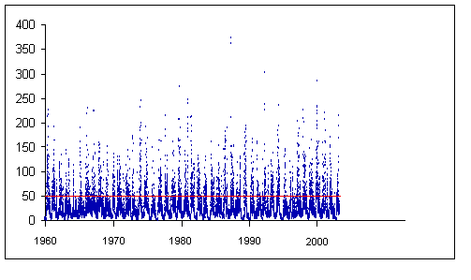
Figure 3.2 Mean Daily Flows for the River Teifi.

3.5.3 Threshold Choice
The choice of the threshold u consists of a trade off between bias and variance. A threshold too low and the asymptotic basis of the model is violated, leading to bias; too high will generate few extremes which leads to high variance. Cole (2001) writes that standard practice is to adopt as low a threshold as possible subject to the limit model providing a reasonable approximation.
There are two methods available to choose the threshold: an exploratory technique carried out prior to model estimation and the other an assessment of stability of parameter estimates based on the fitting of models across a range of different thresholds.

The first method is based on the mean of the GPD. Assume the GPD is a valid model for the threshold excesses generated by a series X₁,…, X_{n}. Let X be an arbitrary term of this series.
$$E\left(X−u_{0}|X>u_{0}\right)=\frac{σ_{u_{0}}}{1−ξ}$$

$σ_{u_{0}}$ denotes the scale parameter corresponding to the excesses over threshold u₀. If the GPD is valid for the excesses over a threshold u₀ then it should also be valid for any threshold u > u₀. Hence:
$$\begin{aligned}E\left(X−u|X>u\right)=\frac{σ_{u}}{1−ξ} \\ \end{aligned}$$
$$=\frac{σ_{u_{0}}+ξu}{1−ξ}$$

For u > u_{0 ,} $E\left(X−u|X>u\right)$ is a linear function of u and simply the mean of the excesses of the threshold u. These estimates are expected to change linearly with u at levels for which the generalised Pareto model is appropriate. This leads to the following:

$\left\{\left(u,\frac{1}{n_{u}}\sum_{i=1}^{n_{u}}{\left(x_{(i)}−u\right)}\right):u<x_{\text{max}}\right\}$ (3.10)
x₍₁₎,…, $x_{\left(n_{u}\right)}$ are the observations which exceed u and x_{max} is the largest of the X_{i} . The locus of points given by (3.10) is known as the mean residual life plot. The mean residual life plot should be approximately linear where the GPD is a valid model for the excesses. However interpretation of the mean residual life plot is not always easy in practice.

The second method involves fitting the GPD over a range of thresholds. Similarly to the first method we expect excesses over u (where u > u₀) to follow a GPD if excesses over u₀ do so. The shape parameters of the two distributions are identical. Let σ_{u} be the scale parameter of the GPD for u:
$$σ_{u}=σ_{u_{0}}+ξ\left(u−u_{0}\right)$$

The above suggests that σ changes with u unless ξ = 0. Reparameterising the generalised Pareto scale parameter overcomes this difficulty, so that:

σ* = σ_{u} – ξu

As a result estimates of σ* and ξ should be constant above u₀ provided u₀ is an appropriate threshold value for which excesses will follow the GPD. The estimates for σ* and ξ together with their confidence intervals can then be plotted against u. One can then select u₀ which is the lowest value of u for which the estimates remain near-constant.

3.5.4 Parameter Estimation
Once a threshold has been selected using either or both of the above methods one can obtain estimates of the GPD parameters using maximum likelihood.
Let y₁,…, y_{k} be the k excesses over the threshold u.
For ξ ≠ 0 the log-likelihood of the GPD is:

$ℓ\left(σ,ξ\right)=−k\text{ log}σ−\left(1+\frac{1}{ξ}\right)\sum_{i=1}^{k}{\text{log}\left(1+\frac{{ξy}_{i}}{σ}\right)}$
For ξ = 0 the log-likelihood is:
$$ℓ\left(σ\right)=−k\text{ log }σ−σ^{−1}\sum_{i=1}^{k}{y_{i}}$$

Maximisation is not possible but numerical techniques can be used to obtain parameters from the above equations.

3.5.5 Return Levels
Return levels can be estimated if the GPD is an appropriate model for threshold exceedances. Let x_{m} be the level that is exceeded on average once every m observations then:
$x_{m}=\begin{aligned}\left\{u+\frac{σ}{ξ}\left[{\left({mζ}_{u}\right)}^{ξ}−1\right] ξ≠0 | \right.\end{aligned}$ (3.11)

where ζ is the probability of an individual observation exceeding u and can be estimated by the sample proportion exceeding u:
${\hat{ζ}}_{u}=\frac{k}{n}$ ,
whilst σ and ξ can be substituted with their corresponding maximum likelihood estimators. The number of exceedances over u can be said to follow the binomial distribution making ${\hat{ζ}}_{u}$ a maximum likelihood estimate of ζ_{u}. The variance of ${\hat{ζ}}_{u}$ can be approximated by ${\hat{ζ}}_{u}\left(1−{\hat{ζ}}_{u}\right)/n$.
The variance-covariance matrix for $\left({\hat{ζ}}_{u},\hat{σ},\hat{ξ}\right)$ is approximately:

$$V=\left[\begin{matrix}{\hat{ζ}}_{u}\left(1−{\hat{ζ}}_{u}\right)/n & 0 & 0 \\ 0 & v_{1,1} & v_{1,2} \\ 0 & v_{2,1} & v_{2,2}\end{matrix}\right]$$

where v_{i,j} is the (i,j) term of the variance covariance matrix of $\hat{σ}\text{ and \{}\hat{ξ}$.
The variance of x_{m} can be obtained using the delta method:

$\text{Var}\left({\hat{x}}_{m}\right)≈∇x_{m}^{T}V∇x_{m}$ (3.12)
where:
$\begin{aligned}∇x_{m}^{T}=\left[\frac{∂x_{m}}{∂ζ_{u}},\frac{∂x_{m}}{∂σ},\frac{∂x_{m}}{∂ξ}\right] \\ \\ \left[{σm}^{ξ}ζ_{u}^{ξ−1},ξ^{−1}\left\{{\left({mζ}_{u}\right)}^{ξ}−1\right\},−{\text{σξ}}^{−2}\left\{{\left({mζ}_{u}\right)}^{ξ}−1\right\}+{\text{σξ}}^{−1}{\left({mζ}_{u}\right)}^{ξ}\text{log}\left({mζ}_{u}\right)\right]\text{.}\end{aligned}$

    - Model Checking
Probability plots, quantile plots, return level plots and density plots can all be used to assess the validity of the generalised Pareto model fitted to the data.
The probability plot consists of the following points:

$$\left\{\left(i/{\left(k+1\right)},\hat{H}\left(y_{(i)}\right)\right) i=1,\text{.}\text{.}\text{.},k\right\}$$

where $\hat{H}(y)=1−{\left(1+\frac{\hat{ξ}y}{\hat{σ}}\right)}^{−1/\hat{ξ}}$ is the estimated model and y_{(i)} the excesses over a threshold u.
The quantile plot consists of: $\left\{\left({\hat{H}}^{−1}\left(i/\left(k+1\right)\right),y_{(i)}\right),i=1,\text{.}\text{.}\text{.},k\right\}$
where ${\hat{H}}^{−1}(y)=u+\frac{\hat{σ}}{\hat{ξ}}\left[y^{−\hat{ξ}}−1\right]$.
If the generalised Pareto model is valid for the excesses then both the probability and quantile plots will be approximately linear.

A return level plot consists of the locus of the points: $\left\{\left(m,{\hat{x}}_{m}\right)\right\}$for large values of m and the estimated m-observation return level given by:

$${\hat{x}}_{m}=u+\frac{\hat{σ}}{\hat{ξ}}\left[\left({mζ}_{u}−1\right)\right]$$
It is usual to plot these on a logarithmic scale to emphasise the effect of extrapolation and also to add confidence intervals and empirical estimation of the return levels.
Finally one can compare the histogram of threshold exceedances to the density function of the fitted Pareto model.

Chapter 4: Data Analysis

The data used here consists of the daily mean flows of the river Teifi at Glan Teifi from 1960 to 2003. The river flooding analysis will consist of two stages. The first of these is the method of estimating the unknown parameters of a model and maximum likelihood estimation has been chosen. Following this a goodness of fit test will be applied to find how well a model performs in representing extreme values already observed. This will consist of the diagnostic plots as discussed in chapter 3. In order to make maximum use of the data, different models will be applied, namely the block maxima model, r largest order statistic model and exceedances over a threshold model.

The analysis was carried out using the “Extremes Toolkit” in “R”, “Extremes 3.0” and “Microsoft Excel”. R can be downloaded from http://www.r-project.org/ and the Extremes Toolkit is available from http://www.esig.ucar.edu/extremevalues/evtk.html .
Appendix B explains how the Extremes Toolkit was used for the data analysis.

4.1 Annual Maxima
Figure 4.1 illustrates the annual maximum flows of the Teifi over the period 1960 to 2003. The pattern of variation has not changed much over the observation period and for this reason the data can be modelled as independent observations from a GEV distribution.

Figure 4.1: Scatter plot of Teifi Annual Maximum Flows
0
50
100
150
200
250
300
350
400
1955
1960
1965
1970
1975
1980
1985
1990
1995
2000
2005
2010
Year
Annual Maximum Mean Flow (m³s⁻¹)

The table below shows the parameter estimates, obtained by maximising the GEV
log-likelihood for the data, together with standard errors for each parameter.

Parameter | Estimate | Standard Error
Location (μ) | 155.92467 | 7.53352
Scale (σ) | 44.10927 | 5.53167
Shape (ξ) | 0.01843 | 0.11694

The corresponding approximate 95% confidence intervals for each parameter are as follows:

$\hat{μ}=\left[\text{141}\text{.}\text{1589708},\text{170}\text{.}\text{6903692}\right]$
$$\hat{σ}=\left[\text{33}\text{.}\text{2671968},\text{54}\text{.}\text{9513432}\right]$$
$$\hat{ξ}=\left[−0\text{.}\text{2107724},0\text{.}\text{2476324}\right]$$

As discussed in 3.2 the shape parameter determines the extreme value distribution. There is strong evidence that the annual maxima can in fact be modelled by a Gumbel distribution as the confidence interval for ξ contains 0.
In order to confirm this, a Gumbel distribution was applied to the river flows. Parameters were estimated to be: $\hat{μ}=\text{156}\text{.}\text{358}$ and$\hat{σ}=\text{44}\text{.}\text{3862}$. Both are almost the same as the estimates initially given under the GEV model. To check this further a likelihood ratio test (Reiss and Thomas, 2001) was carried out at a 5% significance level:
H₀ : ξ = 0 H₁ : ξ ≠ 0

Test statistic: $2\text{log}\frac{\prod_{i=1}^{n}{g_{\hat{μ},\hat{σ},\hat{ξ}}(x_{i})}}{\prod_{i=1}^{n}{g_{\hat{μ},\hat{σ},0}(x_{i})}}$

Where $g_{\hat{μ},\hat{σ},\hat{ξ}}(x_{i})$ $g_{\hat{μ},\hat{σ},0}(x_{i})$ are the probability density functions of the GEV and Gumbel distribution respectively. $\hat{μ},\hat{σ},\hat{ξ}$ denote the maximum likelihood estimators.
The p-value is given by:
$$1−χ_{1}^{2}\left(2\text{log}\frac{\prod_{i=1}^{n}{g_{\hat{μ},\hat{σ},\hat{ξ}}(x_{i})}}{\prod_{i=1}^{n}{g_{\hat{μ},\hat{σ},0}(x_{i})}}\right)$$
The likelihood ratio test gave a p-value of 0.874288 hence the null hypothesis is not rejected and there is strong evidence to suggest a Gumbel distribution is appropriate.

The profile likelihood can provide more accurate confidence intervals. To obtain the profile log-likelihood for the shape parameter, let ξ = ξ₀ and maximise the log-likelihood (3.3) with respect to μ and σ. Repeating this for various ξ and the corresponding maximised values give the profile log-likelihood for ξ. Figure 4.2 shows the profile log-likelihood for ξ from which an approximate 95% confidence interval for ξ is [-0.17378, 0.28602]. The interval is of similar width to the one given by the log-likelihood method but it is shifted to the right corresponding to the skewness as seen in the Profile Log-likelihood plot.

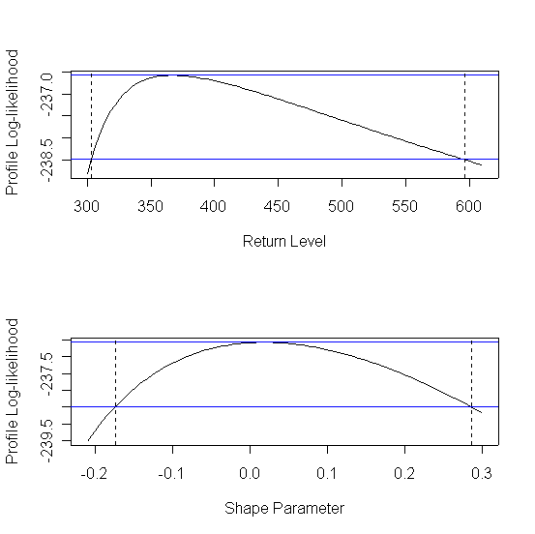
Figure 4.2: Profile Log-likelihood for ξ

The graphical goodness of fit tests are shown in figure 4.3. The probability plot is near linear and close to the unit diagonal suggesting that the GEV model with the above parameters is a good fit. The quantile plot is also near linear which also suggests the model is acceptable. The return level plot as expected (because ξ is close to 0) displays a high degree of linearity. This also confirms that the annual maxima can be successfully modelled by a Gumbel distribution. The return level plot also provides an estimate for the 100 year return period as 367.6824m³s⁻¹. A good fit is also confirmed by the density plot where the histogram of the data is seemingly consistent with the density estimate.

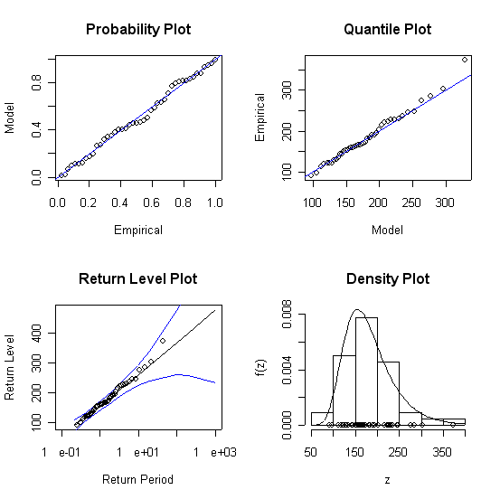
Figure 4.3: Diagnostic Plots for Fitted GEV Model

The 100 year return level can be estimated using the delta method.
Putting in the estimated parameters into equations (3.5) and (3.6) the following estimates are obtained:

$${\hat{z}}_{0\text{.}\text{01}}=\text{ 408}\text{.}\text{036508}$$

$$\text{Var }({\hat{z}}_{0\text{.}\text{01}})=\text{778181}\text{.}\text{8173}$$

An approximate 95% confidence interval can then be calculated as follows:

408.036508 ± 1.96 × √778181.8173 = [-1320.969932, 2137.042948]
Unfortunately this method provides a very poor approximation for long return periods, as the above shows. It is once again better to use the profile log-likelihood. Cole (2001) explains that in order to obtain the profile log-likelihood for return levels the GEV model requires a reparameterization so that z_{p} is one of the model parameters. The reparameterization is obtained by substituting μ in (3.3) with (3.7). Hence the GEV is now in terms of (z_{p}, σ, ξ) and the profile log-likelihood is found by maximising the log-likelihood with respect to ξ and σ for various values of z_{p}. The profile log-likelihood for the Teifi data is shown below:
Figure 4.4 Profile log-likelihood for the return level (z_{p})

The approximate 95% confidence interval for the 100 year return level, as given by the profile log-likelihood, is [303.12671, 595.8311]. Discrepancies arose in the delta method because a normal approximation was used despite the clear asymmetry present in the profile log-likelihood. Additionally the very large variance of ${\hat{z}}_{0\text{.}\text{01}}$ suggests the inaccuracy is also due to higher order terms being ignored in the delta method.

4.2 The r Largest Order Statistic Model
The data used in this analysis consists of the 10 largest flows each year between 1960 and 2003 as shown in figure 4.5.

Flow (m³/s⁻¹)
10 largest annual flows
0
50
100
150
200
250
300
350
400
1955
1960
1965
1970
1975
1980
1985
1990
1995
2000
2005
2010
Year
Figure 4.5 10 largest annual river flows 1960 - 2003

The probability distribution function (3.9) could then be applied for r = 1, …, 10 and maximisation of the log-likelihood (section 3.4.2) provided the parameter estimates as shown in table 4.6.

R | Location parameter estimate (μ) | Standard Error  (μ) | Scale Parameter Estimate  (σ) | Standard Error  (σ) | Shape Parameter Estimate (ξ) | Standard Error  (ξ)
1 | 155.92467356 | 7.533505 | 44.10927026 | 5.531664 | 0.01842763 | 0.116941
2 | 175.00042387 | 6.292564 | 43.36764703 | 3.967482 | 0.02525835 | 0.082531
3 | 183.59278904 | 5.598584 | 42.04151785 | 3.304444 | -0.02769651 | 0.059783
4 | 187.60167205 | 5.272966 | 41.30717995 | 2.973663 | -0.05341362 | 0.049418
5 | 189.70616504 | 5.010904 | 40.23744635 | 2.828355 | -0.05284793 | 0.045013
6 | 191.971109 | 4.817898 | 39.360708 | 2.657366 | -0.060824 | 0.040610
7 | 192.91752790 | 4.702983 | 38.86891090 | 2.647059 | -0.05518991 | 0.039439
8 | 192.88097106 | 4.643061 | 38.70478569 | 2.718559 | -0.04428389 | 0.039453
9 | 193.56780871 | 4.552892 | 38.25907440 | 2.651316 | -0.04542065 | 0.037202
10 | 195.32189302 | 4.447003 | 37.82606673 | 2.386544 | -0.07027444 | 0.032651

Table 4.6 Maximum Likelihood estimators for r largest order statistic model

Table 4.6 shows that for larger values of r the standard errors clearly decrease corresponding to increased model precision. The lack of stability in the parameter estimates suggests that the model is not a good fit.

This poor fit is shown further in the return level curves in figure 4.7. Apart from the case where r = 1 (corresponding to the annual maxima already analysed in section 4.1) the plots below bring into doubt the validity of the model.

Since the parameters in the r largest order statistic model correspond to those of the GEV annual maxima it is not surprising that using r = 1 obtained a good fit. The bias variance trade-off is also illustrated in the return level plots as the model appears to become a worse fit as r increases.

r = 1 r = 2
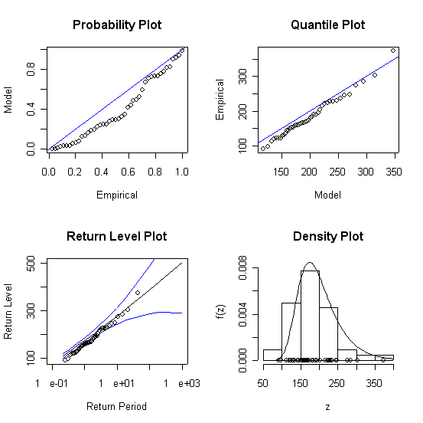
r = 3 r = 4
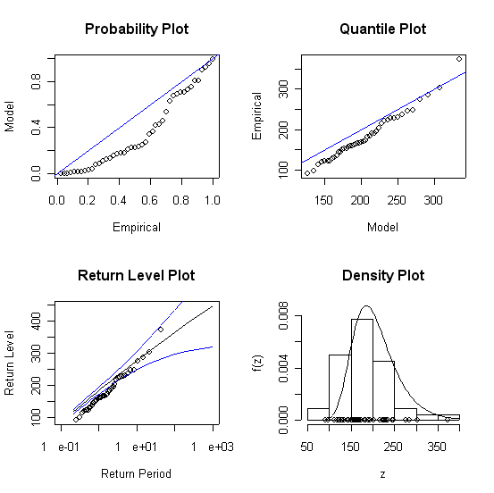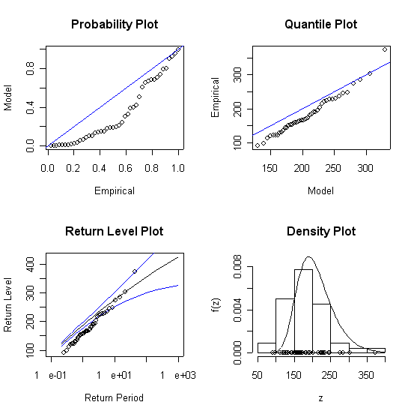
r = 5 r = 6
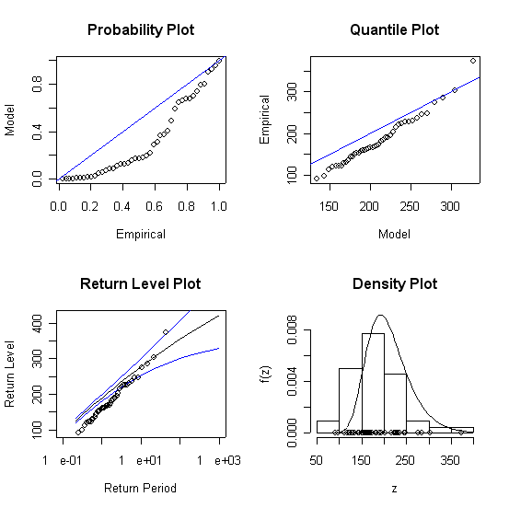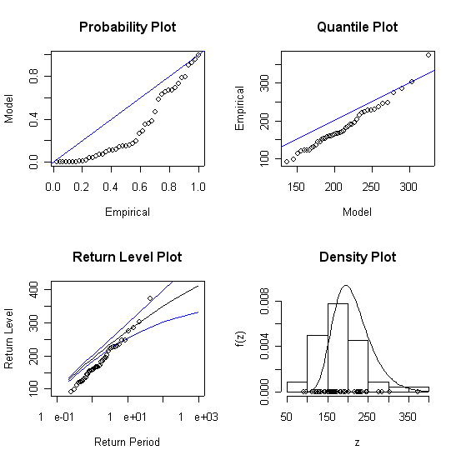
r = 7 r = 8
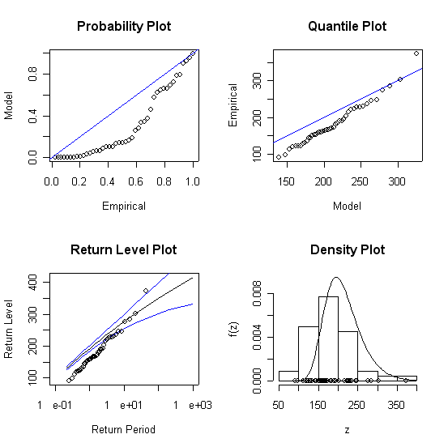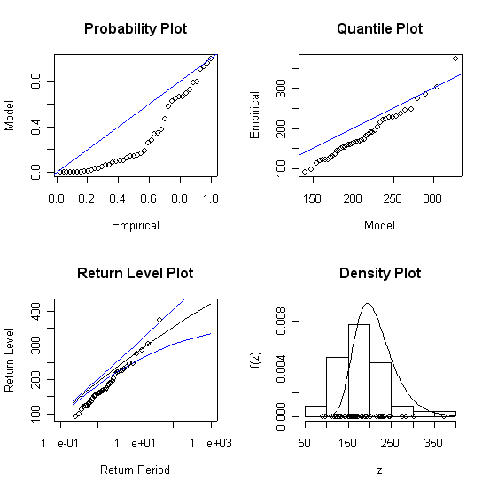
r = 9 r = 10
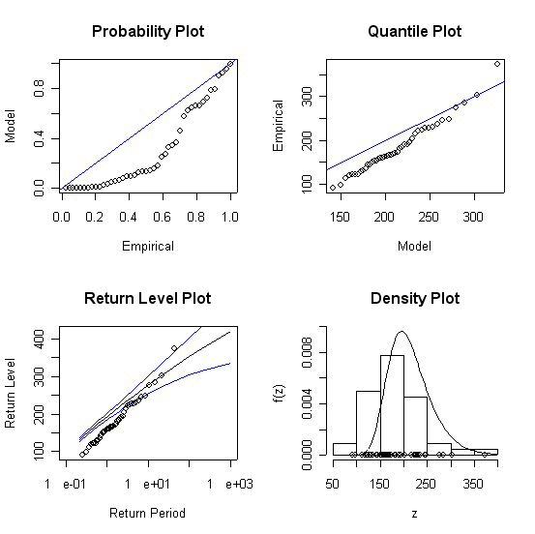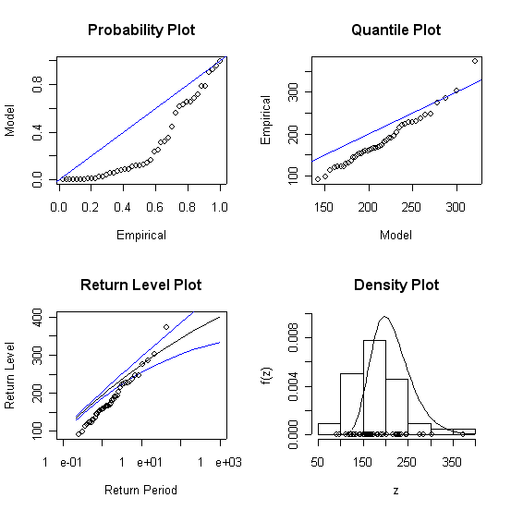

Figure 4.7 Return level Plots with 95% confidence intervals for fitted r largest order statistic model
Finally probability plots and quantile plots were obtained to confirm the model is not a good fit for the Teifi data. Figure 4.8 illustrates how the model becomes a worse fit as r increases.
r = 2
r = 5
r = 10
Figure 4.8 Probability plots and quantile plots for r largest order statistic model.

Clearly the r largest order statistic model is not appropriate for the data. The next step is to consider exceedances over a threshold.
4.3 Exceedances over a Threshold

The first stage involves determining a threshold u. For this purpose a mean residual life plot was drawn (figure 4.9) together with 95% confidence intervals, for thresholds ranging from 0 to 370m³s⁻¹. The plot is approximately linear for values of u between 25 and 175m³s⁻¹ and for this reason 25 was chosen as the threshold.
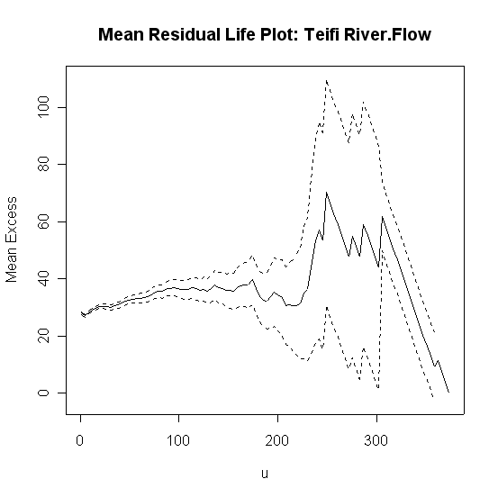
Figure 4.9: Mean residual Life Plot for Teifi Data

Additionally parameter estimates σ, ξ were plotted against threshold values for u between 0 and 50m³s⁻¹ (figure 4.10). These estimates are near constant at u = 25 confirming this is an appropriate choice.

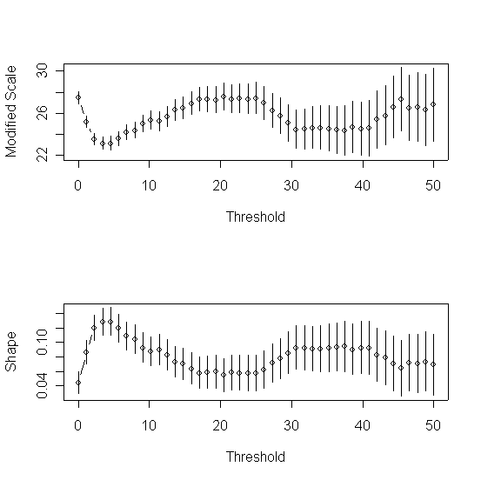
Figure 4.10: Parameter Estimates against threshold for Teifi data

Having established a threshold the next stage involved fitting a GPD to the exceedances over 25m³s⁻¹. Maximising the GPD log-likelihood provided the following parameter estimates:

Parameter | Estimate | Standard Error
Scale (σ) | 28.8132817 | 0.52101596
Shape (ξ) | 0.0572038 | 0.01305416

The corresponding approximate 95% confidence interval estimates for each parameter are as follows:
$$\hat{σ}=\left[\text{27}\text{.}\text{7920904184},\text{29}\text{.}\text{834472}\right]$$
$$\hat{ξ}=\left[0\text{.}\text{0316176464},0\text{.}\text{0827899536}\right]$$
The maximum likelihood estimator of ξ corresponds to an unbounded distribution as the 95% confidence interval for ξ is exclusively in the positive domain.
Once again it is possible to look at the profile log-likelihood for a more accurate confidence interval estimate.
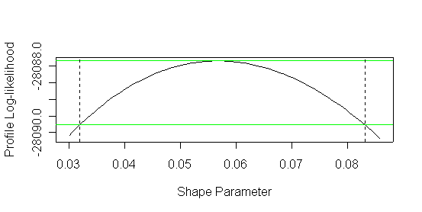
Figure 4.11: Profile Log-likelihood for ξ

The profile log-likelihood provides the following 95% confidence interval for ξ:
[0.032, 0.08316] which is identical (to 2 d.p.) to that given by maximum likelihood estimation.

The diagnostic plots are shown in figure 4.12. The probability and quantile plots are linear confirming the model is a good fit. The return level plot also suggests a good fit and provides 392.5174m³s⁻¹ as an estimated 100 year return level.
Comparison of the density function and histogram of the data also suggests a good fit.

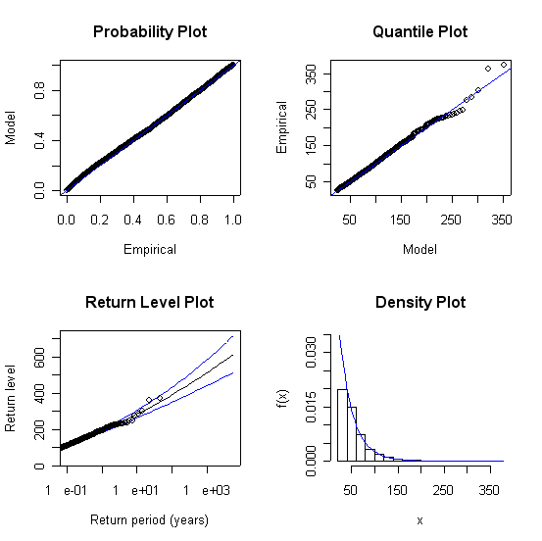
Figure 4.12: Diagnostic Plots for the Fitted Threshold Model

The number of observations over a threshold of 25 is 6357 out of a total of 16071. This provides the following maximum likelihood estimate for the exceedance probability:

${\hat{ζ}}_{\text{25}}=\frac{\text{6357}}{\text{16071}}=0\text{.}\text{3955572149}$

The 100 year return level and its confidence intervals can be estimated using equations (3.11) and (3.12):

$${\hat{x}}_{\text{100}}=\text{392}\text{.}\text{4833161}$$

Var $\left({\hat{x}}_{\text{100}}\right)$= 1380.833023
The 95% confidence intervals can then be calculated:

392.4833161 ± 1.96 × √1380.833023 = [319.6505752, 465.316057]

This may not be reasonable as in the 43rd year of observation the lower interval limit of 319.65 was exceeded twice. It is therefore useful to look at the profile log-likelihood.
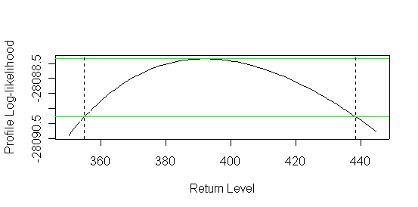
Figure 4.13: Profile log-likelihood for the return level (x_{p})

The 95% confidence interval for the 100 year return level, as given by the profile log-likelihood, is [355.06522, 438.42574]. This is much narrower than the estimate obtained with the log-likelihood method with a more plausible lower bound.

Chapter 5: Further Analysis

In order to discover more about any patterns that may be present in the Teifi river data a further analysis was carried out using the exceedances over a threshold model. The data was divided into 10 year intervals as follows: 1960-69, 1970-79, 1980-89 and 1990-99. The analysis was carried out using the “Extremes Toolkit” in “R”. For each decade a mean residual life plot was produced as shown in figure 5.1.

Mean Residual Life Plot: 1960 – 1969 Mean Residual Life Plot: 1970 - 1979
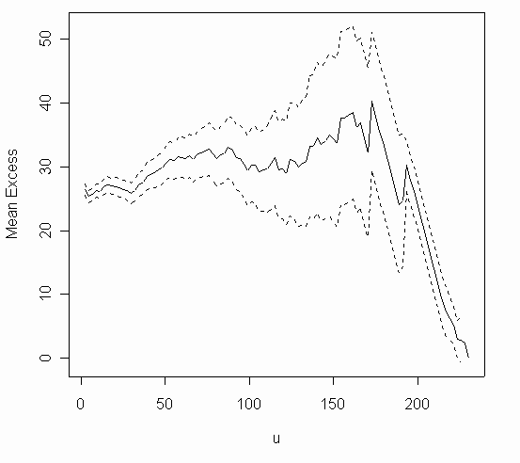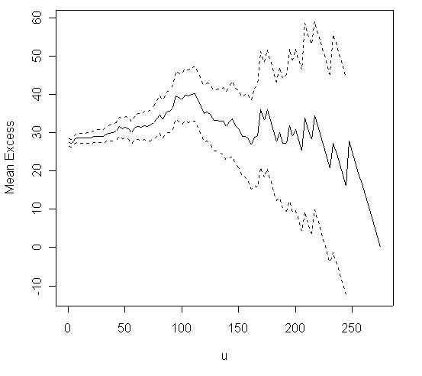
Mean Residual Life Plot: 1980 – 1989 Mean Residual Life Plot: 1990 - 1999
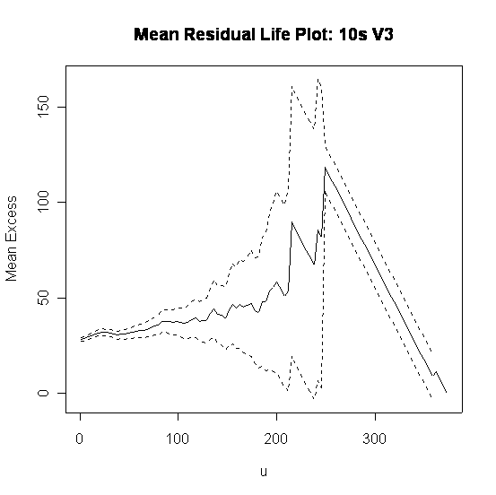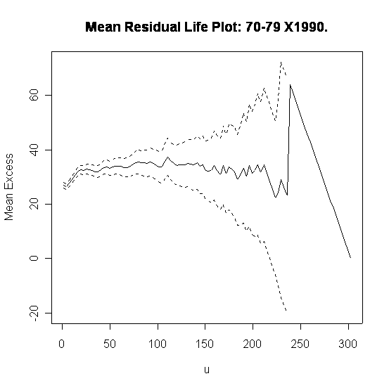

Figure 5.1 Mean Residual Life Plots for each decade

In order to determine threshold values parameter estimates σ and ξ were plotted against threshold values. The thresholds (u), given below, were chosen by looking at where these estimates were near constant.

Decade | Threshold (u)
1960 to 1969 | 20
1970 to 1979 | 12
1980 to 1989 | 10
1990 to 1999 | 20

Having established the thresholds a GPD could be fitted for each period with parameters found using maximum likelihood estimation. The tables below show the resulting parameter estimates together with their standard errors (SE) and 95% confidence intervals (CI):

Decade | Estimate (σ) | SE (σ) | CI (σ)
1960 - 69 | 25.26754550 | 0.85821729 | [23.585439612, 26.949651388]
1970 - 79 | 26.91613271 | 0.80295012 | [25.342350475, 28.489914945]
1980 - 89 | 27.90501869 | 0.81467691 | [26.308251946, 29.501785434]
1990 - 99 | 31.66572683 | 1.14346519 | [29.424535058, 33.906918602]

Decade | Estimate (ξ ) | SE (ξ) | CI (ξ)
1960 - 69 | 0.0591141 | 0.02458539 | [0.0109267356, 0.1073014644]
1970 - 79 | 0.05533505 | 0.02157475 | [0.01304854, 0.09762156]
1980 - 89 | 0.06791527 | 0.02130258 | [0.0261622132, 0.1096683268]
1990 - 99 | 0.02518987 | 0.02601701 | [-0.0258034696, 0.0761832096]

In order to observe what is happening to the parameters the following graphs were plotted:

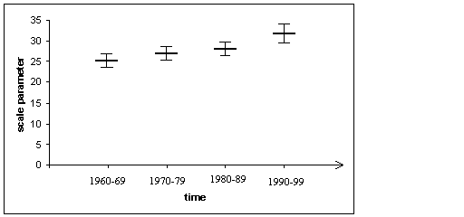
Figure 5.2: σ estimates with 95% confidence intervals

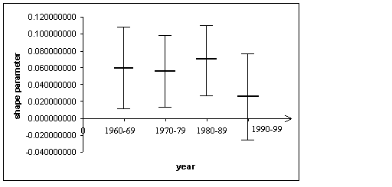
time
Figure 5.3: ξ estimates with 95% confidence intervals

The scale parameter is increasing each year. The shape parameter on the other hand is between 0.055 and 0.068 for the first three decades and then decreases to 0.025 between 1990 and 1999. However the confidence intervals show that over the period the variation in the shape parameter is not significant.

Figure 5.4 consists of the diagnostic plots for each period and observations are noted below.

1960-69
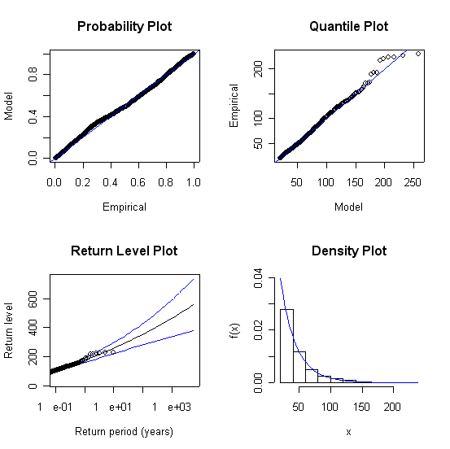
1970-79
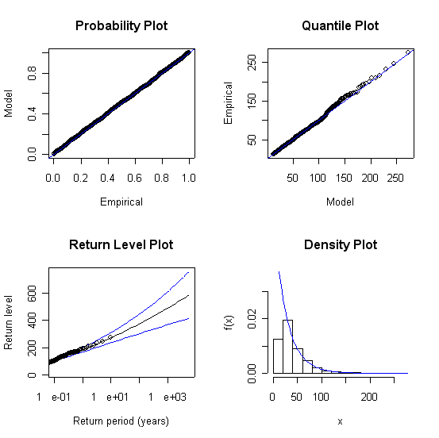

1980-89
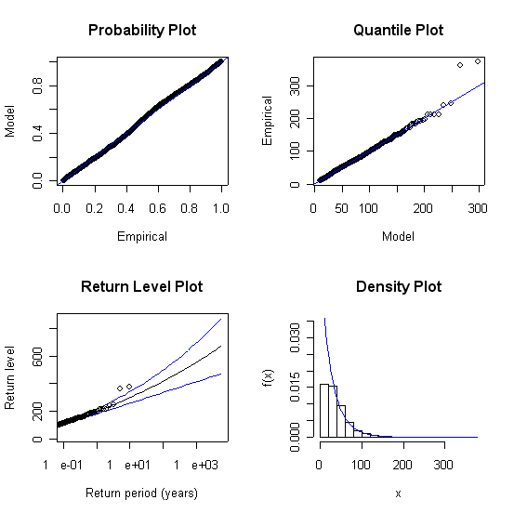
1990-99
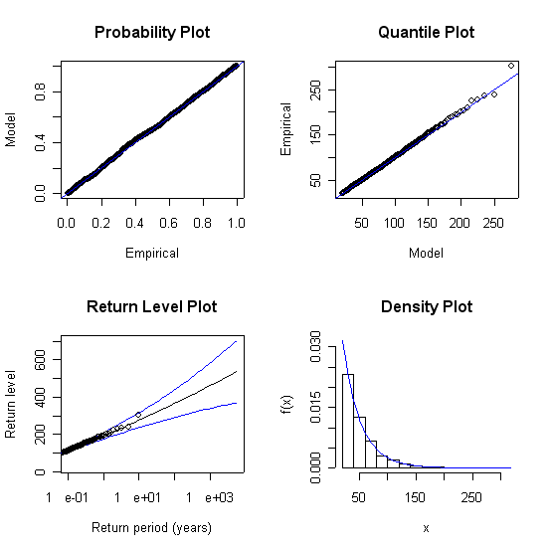
Figure 5.4 Diagnostic Plots for each decade.
All four probability plots are linear and on the unit diagonal. The near linear quantile plots also suggest good model fit. A comparison of density plots with histograms of the data show good fits in the decades: 1960-69 and 1990-99. Although these are worse for 1970-79 and 1980-89 they are still acceptable. Overall it can be seen that the GPD was successfully fitted to each decade.

Trends were also looked for in the return periods and return levels. The 100 year return levels, found using equation (3.11), are given below:

Decade | 100 year return level
1960 - 69 | 355.689385768
1970 - 79 | 374.490072660
1980 - 89 | 416.368983794
1990 - 99 | 366.942023152

Overall the 100 year return level has increased suggesting that higher river levels can be expected compared to 40 years ago. An interesting observation was made regarding return periods. The bankfull flow for the Teifi is given as 210m³s⁻¹. Equation (3.11) was rearranged to:

$r=\text{exp}\left\{\frac{1}{ξ}\text{ln}\left[\frac{\left(\text{210}−u\right)ξ}{σ}+1\right]−\text{ln}(\text{365}ζ)\right\}$ where r is the return period in years

By putting in values for σ, ξ, ζ and u the following results were obtained:

Decade | Return Period (years)
1960 - 69 | 2.777300068
1970 - 79 | 2.039816025
1980 - 89 | 1.376827355
1990 - 99 | 1.677927409

Although 1980-1989 has the shortest return period this may be due to very high river flow levels witnessed that year. The greatest daily mean flow for the Teifi between 1959 and 2004 occurred in October 1987. At 373.6 m³/s⁻¹ it is an exceptionally high level and may have affected the final result. In fact the peak flow achieved that day was recorded as 448.8 m³/s⁻¹.

Overall, it is clear that the bankfull level is being achieved more frequently each year. Hence one could argue that the area is under greater risk of flooding. As mentioned in Chapter 2 various parties argue that overall flood risk is increasing each year and this can clearly be seen for the Teifi. Insurance providers can use such information to help establish premiums that reflect risk more accurately.

Chapter 6: Conclusion

6.1 Final Comments
Initial planning for this dissertation included an analysis of flood insurance premiums and claims data. In spite of extensive efforts there were problems obtaining this information from insurance companies which meant that such an analysis could not be carried out. However an ABI (2002) report did contain an indication of average premiums and claims, from which it is possible to learn something about the current nature of flood claims data. The ABI’s figures indicated that a £1000 excess reduces the mean claim by 10% and a £5000 excess leads to a 25% reduction.

Let: c be the pure premium
E[X] the mean claim payment
p the probability of receiving a claim
d the policy excess
c’ the reduced premium following the introduction of an excess
E[Y] the mean claim payment made by the property owner

c = E[X] × p (6.1)

Introducing an excess d leads to:

c’ = E[Y] × p × Probability (loss > d occurs) (6.2)

Information to hand suggests setting E[X] = £20,000. Using (6.2) and assuming an excess of £1000:
0.9 c = E[Y] × p × p(loss > 1000)
substituting in (6.1): 0.9 E[X] × p = E[Y] × p × p(loss > 1000)
cancelling p: 0.9 × 20000 = E[Y] × p(loss > 1000)
18000 = E[Y] × S(1000) (6.3)
where S is the survival function of Y

Similarly for an excess of £5000:
15000 = E[Y] × S(5000) (6.4)
Using equations (6.3) and (6.4) it is possible to fit a distribution and use it to simulate claim data, thus eliminating the need for actual figures.

One would expect flood insurance claims data to be dominated by large claims and hence best modelled by a skewed distribution with a long right-hand tail.
Firstly the Pareto distribution was fitted to the data.

Let X ~ Pareto (α, λ) λ > 0, α > 0

$f(x)=\frac{{\text{αλ}}^{α}}{(λ+x)^{α+1}}$ $F(x)=1−{\left(\frac{λ}{λ+x}\right)}^{α}$

$$E\left[X\right]=\frac{λ}{α−1}=\text{20000} ∴λ=\text{20000}(α−1)$$

$g(y)=\frac{f(y+d)}{1−F(d)}=\frac{\frac{{\text{αλ}}^{α}}{(λ+y+d)^{α+1}}}{{\left(\frac{λ}{λ+d}\right)}^{α}}=\frac{α(λ+d)^{α}}{(λ+y+d)^{α+1}}$

Hence Y ~ Pareto(α, λ + d)

(6.3) can be simplified as follows:

$\text{18000}=\frac{λ+\text{1000}}{α−1}×{\left(\frac{λ}{λ+\text{1000}}\right)}^{α}$

$\text{18000}=\frac{λ^{α}{\left(λ+\text{1000}\right)}^{1−α}}{α−1}$

Substituting in for λ:

$\text{18000}=\frac{{\text{20000}}^{α}(α−1)^{α}(\text{20000}(α−1)+\text{1000})^{1−α}}{α−1}$

$\text{18000}=\frac{{\text{20000}}^{α}(\text{20000}(α−1)+\text{1000})^{1−α}}{(α−1)^{1−α}}$

$\text{18000}=\frac{{\text{20000}}^{α}(\text{20000}(α−1)+\text{1000})^{1−α}}{(α−1)^{1−α}}×\frac{\text{20000}}{\text{20000}}$

$\text{18000}=\frac{(\text{20000}(α−1)+\text{1000})^{1−α}}{(α−1)^{1−α}(\text{20000})^{1−α}}×\text{20000}$

$\frac{9}{\text{10}}={\left(\frac{(\text{20000}(α−1)+\text{1000})}{(α−1)(\text{20000})}\right)}^{1−α}$

$0\text{.}9={\left(1+\frac{1}{\text{20}(α−1)}\right)}^{1−α}$

Further calculations showed that no values for α gave 0.9 on the LHS. In fact it became clear that the LHS tends to about 0.95.
By repeating the above for an excess of £5000 and reduction in claim of 25% (6.4) simplified as follows:

$$0\text{.}\text{75}={\left(1+\frac{1}{4(α−1)}\right)}^{1−α}$$

Here α = 0 and again it seems the Pareto distribution is not a suitable model.

The next attempt involved fitting the exponential distribution.
Let X ~ exponential (λ) λ > 0

$f(x)={λe}^{−λx}$ $F(x)=1−e^{−λx}$

$$E\left[X\right]=\frac{1}{λ}$$

$$g(y)=\frac{f(y+d)}{1−F(d)}=\frac{{λe}^{−λ(y+d)}}{e^{−λd}}={λe}^{−λy}$$

Hence Y ~ exponential (λ)

From (6.3) and (6.4):
$\text{18000}=\frac{1}{λ}×e^{−\text{1000}λ}⇒\frac{\text{18000}}{e^{−\text{1000}λ}}=\frac{1}{λ}$
$\text{15000}=\frac{1}{λ}×e^{−\text{5000}λ}⇒\frac{\text{15000}}{e^{−\text{5000}λ}}=\frac{1}{λ}$
Equating the two: $\frac{\text{18000}}{e^{−\text{1000}λ}}=\frac{\text{15000}}{e^{−\text{5000}λ}}$
$1\text{.}2=e^{\text{4000}λ}$
$λ=\frac{\text{ln}1\text{.}2}{\text{4000}}=0\text{.}\text{0004558}⇒E[Y]=\text{ E}[X]=\text{ 21939}$
This is close to the assumed mean of £20,000 implying that the exponential provides a good model for the claims data. Additionally it suggests that the left hand tail is different to that initially thought and appears that there are far more smaller claims being received by insurers which could explain the choice of excesses such as £1000 and £5000.

Further attempts were made to fit the Weibull and Loglogistic distributions. Attempts to use “Mathematica” to calculate the integrals that determine E[Y] did not prove successful. Many of the equations typed into Mathematica input were simply copied into the output with no solution given. However, as discussed above, the analysis still gave some interesting information about the left hand tail of the flood claims distribution. It is therefore possible that with actual insurance data and different software one could investigate this further.

6.2 Conclusion
Flood risk is increasing each year. As more locations become prone to flooding a greater number of people will either be refused insurance or premiums will be so high that they will become unaffordable for most. The ABI has been concerned with this issue for some time and has been looking into possible solutions. There is no doubt that a partnership is required between insurance companies and the Government.

The Government needs to invest even more in flood defences and any future development must occur outside the floodplain. However the former is criticised as some parties feel that flood defences simply shift the water elsewhere resulting in more damage. The main disadvantage of flood barriers is that they are able to stop only a certain severity of flood.

There is no doubt that people living in high risk flood areas must be protected from physical damage and flood defences are the only way to do so. The only other option is to move people, though this seems hardly realistic. Interestingly this has already occurred in the United States in the town of Valmeyer, Illinois. In 1993 the Mississippi River broke its banks and Valmeyer was deluged in early August and remained so until October the same year. Following this the residents voted to move the entire town to higher ground and Valmeyer now lies 400 feet higher and 2 miles further from its original site. In Elba, Alabama town officials are currently deciding whether or not to do the same following the serious flood event in September 2004 (McNew, 2004).

The Government can try to make flood defences better and EVT provides a way of doing so. By analysing past flows one is able to note whether flood risk in a particular area is increasing and how rapid this change in risk is. The estimation of return levels also allows one to calculate the probability of a flood event occurring in a given year. Armed with this information it is possible to design defences that protect against say 500 year return levels (0.2% chance of occurrence in a given year).

If adequate defences are in place insurance companies are then able to continue providing affordable cover for homes and businesses. However this raises another problem; there does not appear to be a common flood defence standard level. The Government, DEFRA and the insurance industry did not appear to agree on the standard of defences following the autumn 2000 floods. Hence it would be recommended to set a single set of minimum standards related to flood defence that could be used by all. Although the ABI states the minimum level to offer residential properties insurance at “normal terms” as a 1 in 200 return period no evidence was found that defences are being built or improved to such a standard. DEFRA, on the other hand, view anything between a 1000 year and 100 year return period as low to medium risk (ABI, 2003).

To illustrate the use of EVT in assessing flood risk an analysis of the River Teifi’s mean daily flows was carried out. The Teifi flows mainly through villages and farmland, from the Cambrian Mountains to Cardigan Bay below the town of Cardigan. The last serious flood event occurred in February 2002 when the Teifi broke its banks in the lower harbour at Cardigan. The daily mean flow that day was recorded as 207.343 m³s⁻¹.

The GEV model provided a good fit for the annual maxima. It also provided a 100 year return level. Additionally a likelihood ratio test confirmed that the data could be modelled by a Gumbel distribution with parameters (156, 44). Fitting the r largest order statistic model did not prove so successful. This was mainly due to the nature of the data. Although annual maxima can be treated as independent observations the maxima for the Teifi tended to occur in the winter and spring. This clustering inevitably affected the validity of the model and explains why the diagnostic plots became more distorted as r increased. For the threshold model a GPD was successfully fitted with parameters (28.81, 0.06). Overall the analysis illustrated that EVT is very useful in modelling river data; establishing trends and return levels.

A further analysis of the Teifi was based on 10 year intervals. For each period the GPD model was fitted to threshold exceedances. The increase in the 100 year return levels prompted the question of whether return periods had changed over time. The bankfull level of 210m³s⁻¹ was used as the return level and calculations revealed that this level is being exceeded more frequently each year. This coincides with the increasing flood risk trend already noted by various parties, as discussed in chapter 2. Not only does EVT help recognise such a trend it provides estimates as to how much lower or higher a return level or period is.

However EVT is by no means a perfect solution and does have its limitations. It was clear that the r largest order statistic model was unsuitable due to clustering present in the river data. Clearly the assumption that observed values are identically and independently distributed is easily violated in practice. Secondly when modelling threshold exceedances the subjective choice of u will never be perfect. In the decade analysis of chapter 5 the initial choice for the threshold u in years 1980 – 1989 provided a very poor fit and unrealistic confidence intervals for the GPD parameters.

Despite criticisms, EVT can provide ways to improve flood forecasting techniques. The Government is clearly investing more in flood defence and more accurate information regarding return periods aids in the building of structures designed to withstand levels expected in a specified area. Furthermore, locations and their flooding potential can be analysed prior to construction of any buildings. Insurers armed with more information regarding return periods have a better idea of the risk involved and thus are able to calculate premiums more accurately. Premiums also depend on claim size and so it is useful to be aware of patterns in claim amounts. Data available suggested that average claims may be smaller than anticipated and more accurate figures would enable further research into this. Information regarding claim patterns together with predicted flooding return levels and periods can lead to more precise premium calculations in the future.

References

Association of British Insurers. (July 2003). Development Planning and Flood Risk (PPG 25) Association of British Insurers’ Guidance on Insurance Issues. http://www.abi.org.uk/Display/File/78/PPG25guidance2.pdf [23/07/04]

Association of British Insurers. (2002). The Flood and Coastal Defence Funding Review. The Association of British Insurers’ response to the Defra and National Assembly for Wales’ Consultation Document. http://www.abi.org.uk/Display/File/78/DEFRA_FUNDING_REVIEW.doc [25/08/04]

Association of British Insurers. (November 2001). Flooding: A Partnership Approach to Protecting People. Association of British Insurers. http://www.abi.org.uk/Display/File/301/Flooding_A_-_Partnership_Approach_to_Protecting_People.doc [23/07/04]

BBC. (22/04/04). Flooding cost ‘may rise 20-fold’. http://news.bbc.co.uk/1/hi/uk/3648391.stm [05/08/04]

BBC. (29/07/04). Minister unveils flooding plans. http://news.bbc.co.uk/1/hi/england/3935319.stm [05/08/04]

BBC NEWS (19/02/04) Video games to help flood planners. http://news.bbc.co.uk/1/hi/technology/3500747.stm [05/08/04]

Coles, S. (2001). An Introduction to Statistical Modelling of Extreme Values. 2nd ed. Springer-Verlag, London.

The Economist. (28/08/04). Fog about Floods.

The Economist. (15/11/01). Looks like rain. http://www.economist.com
[13/05/04]

Embrechts, P. Klüppelberg, C. and Mikosch, T. (2003). Modelling Extremal Events for Insurance and Finance. 4th ed. Springer-Verlag, Berlin.

Farrow, P. and Simon, E. (25/04/04). Insurers Home in on Flood and Subsidence Risks. The Sunday Telegraph.

Gilleland, E. (co-author of “Extremes Toolkit”). Personal communication.

Hipel, K. W. & McLeod, A. I. (1994). Time Series Modelling of Water Resources and Environmental Systems. Elsevier, Amsterdam.

Huber, M. (2004). Reforming the UK Flood Insurance Regime. The Breakdown of a Gentlemen’s Agreement. Carr Discussion Paper Nr. 18. http://www.lse.ac.uk/collections/CARR/documents/Default.htm [25/08/04]

McNew, J. G. (08/10/04). Flooded Illinois Town Maintained Community by Moving. Disaster Relief. http://www.disasterrelief.org/Disasters/980402valmeyer1/ [09/10/04]

Mintowt-Czyz, L. and Sanchez, M. (17/08/04). Frantic Hunt for the Missing 15. Evening Standard.

Nagle, G. (2003). Rivers and Water Management. Hoddler & Stoughton, London.

Nugent, H. (03/03/04). Insurers Map Out the Risk of Flood Faced by Homeowners. The Times.

Reiss, R.D. & Thomas, M. (2001). Statistical Analysis of Extreme Values with Applications to Insurance, Finance, Hydrology and Other Fields. 2nd ed. Birkhäuser-Verlag, Germany.

Smith, R, L. (2003) Statistics of Extremes with applications in environment, insurance and finance. http://www.stat.unc.edu/postscript/rs/semstatris.pdf [29/11/03]

Wolstenholme, L. (2003). 106 Teaching Notes.

Bibliography

The Association of British Insurers. Flooding. http://www.abi.org.uk/Display/default.asp?Menu_ID=718&Menu_All=1,714,718 [04/03/04]

Berliner, B. (1982). Limits of Insurability of Risks. Pretince Hall, USA.

Brauner, C. and Menzinger, I. (2002). Floods are Insurable! Swiss Re Focus Report. http://www.swissre.com [17/07/04]

BBC (31/12/02). Flood Insurance Warning. http://news.bbc.co.uk/1/hi/business/2616807.stm [04/03/04]

BBC. (01/02/02). Storms Rage Across Wales. http://news.bbc.co.uk/1/hi/wales/1796003.stm [16/09/04]

The Economist. (17/08/02). Fire, Flood and the Equity Markets.

Environment Agency. Flood Defence. http://www.environment-agency.gov.uk/science/562801/836635/836710/ [29/07/04]

Environment Agency. Risk. http://www.environment-agency.gov.uk/science/562801/836635/836861/ [29/07/04]

Environment Agency. Climate Change. http://www.environment-agency.gov.uk/science/562801/836635/836651/ [29/07/04]

Environment Agency. (January 2004). Teifi Catchment Abstraction Management Strategy. http://www.environment-agency.gov.uk/commondata/105385/teifi_final_e_688607.pdf [16/09/04]

The Faculty of Actuaries and Institute of Actuaries. (2003). Subject 106: Actuarial Mathematics 2, Core Reading

Gaschen, S. Hausmann, P. Mezinger, I. and Schaad, W. (1998). Floods – an insurable risk? A market Survey. http://www.swissre.com [17/07/04]

Gilleland, E. Katz, R. and Young, G. (2003) Extremes Toolkit: Weather and Climate Applications of Extreme Value Statistics. http://www.esig.ucar.edu/extremevalues/tutorial/ [07/06/04]

The Geography Portal. Geographical Dictionary. http://www.kesgrave.suffolk.sch.uk/learningzone/subjects/geography/diction.html
[16/09/04]

Heffernan, J. E. and Tawn, J. A. (2003). An extreme value analysis for the investigation into the sinking of the M. V. Derbyshire. Applied Statistics 52 (3), 337-354

Kent National Grid for Learning. Floods. http://www.kented.org.uk/ngfl/rivers/River%20Articles/floods.htm [17/07/04]

Krzanowski, W. J. (1998). An introduction to Statistical Modelling. Arnold, London.

Lam, L. (2001). An Introduction to S-Plus for Windows. Candiensten, Amsterdam.

Lewes Flood Action (April 2003) Flood Insurance Survey. http://www.lewes-flood-action.org.uk/insurance/surveyresults.html [25/08/04]

National River Flow Archive. Nidd at Birstwith (gauged daily data). http://www.nerc-wallingford.ac.uk/ih/nrfa/webdata/027001/g.html [08/05/04]

National River Flow Archive. Teifi at Glan Teifi (gauged daily data). http://www.nerc- wallingford.ac.uk/ih/nrfa/webdata/062001/g.html [11/05/04]

Property Forum News. (11/02/04). Flood Barriers raise house prices.. http://www.thepropertyforum.net/forum/news110204_01.asp [05/08/04]

Resnick, S. I. (1987). Extreme Values, Regular Variation and Point Processes. Springer-Verlag, New York.

Robson, A and Reed, D. (1999) Flood Estimation Handbook, 3: Statistical Procedures for Flood Frequency Estimation. Institute of Hydrology, UK.

Swiss Re. Autumn 2000 Floods and Storms in the UK. http://www.swissre.com [17/07/04]

Swiss Re. Floods. http://www.swissre.com [17/07/04]

Walmsley, R. M. (1989). Introduction to Standard Fire policies, Special Extensions and Special Perils. Croner Publications Ltd, Kingston.

Wilkinson, S. (2003). Risk Control. Witherbys Publishing, London.

Appendix A: Derivation of Log-likelihoods for the GEV distribution and GPD

The Generalised Extreme Value Distribution: ξ ≠ 0

$\begin{aligned}G(z)=\text{exp}\left\{1−{\left[1+ξ\left(\frac{z−μ}{σ}\right)\right]}^{−1ξ}\right\} \\ g(z)=\frac{d}{\text{dz}}G(z)=\frac{1}{σ}{\left[1+ξ\left(\frac{z−μ}{σ}\right)\right]}^{−1ξ−1}×\text{exp}\left\{−{\left[1+ξ\left(\frac{z−μ}{σ}\right)\right]}^{−1ξ}\right\}\end{aligned}$
$$L=\prod_{i=1}^{m}{g(z)}=\frac{1}{σ^{m}}\prod_{i=1}^{m}{}{\left[1+ξ\left(\frac{z_{i}−μ}{σ}\right)\right]}^{−1ξ−1}\text{exp}\left\{−{\left[1+ξ\left(\frac{z_{i}−μ}{σ}\right)\right]}^{−1ξ}\right\}$$
$\begin{aligned}\text{log}L=\text{log}\left\{\frac{1}{σ^{m}}\prod_{i=1}^{m}{}{\left[1+ξ\left(\frac{z_{i}−μ}{σ}\right)\right]}^{−1ξ−1}\text{exp}\left\{−{\left[1+ξ\left(\frac{z_{i}−μ}{σ}\right)\right]}^{−1ξ}\right\}\right\} \\ −m\text{log}σ+\sum_{i=1}^{m}{\text{log}{\left[1+ξ\left(\frac{z_{i}−μ}{σ}\right)\right]}^{−1ξ−1}−\sum_{i=1}^{m}{{\left[1+ξ\left(\frac{z_{i}−μ}{σ}\right)\right]}^{−1ξ}}} \\ −m\text{log}σ−\left(1+1ξ\right)\sum_{i=1}^{m}{\text{log}\left[1+ξ\left(\frac{z_{i}−μ}{σ}\right)\right]−\sum_{i=1}^{m}{{\left[1+ξ\left(\frac{z_{i}−μ}{σ}\right)\right]}^{−1ξ}}}\end{aligned}$

The Generalised Extreme Value Distribution: ξ = 0

$$\begin{aligned}G(z)=\text{exp}\left[−\text{exp}\left[−\left(\frac{z−μ}{σ}\right)\right]\right] \\ g(z)=\frac{1}{σ}\text{exp}\left[−\left(\frac{z−μ}{σ}\right)\right]\text{exp}\left[−\text{exp}\left[−\left(\frac{z−μ}{σ}\right)\right]\right]\end{aligned}$$

$$L=\prod_{i=1}^{m}{g(z)}=\frac{1}{σ^{m}}\prod_{i=1}^{m}{\text{exp}\left[−\left(\frac{z_{i}−μ}{σ}\right)\right]\text{exp}\left[−\text{exp}\left[−\left(\frac{z_{i}−μ}{σ}\right)\right]\right]}$$

$$\begin{aligned}\text{log}L=\text{log}\left\{\frac{1}{σ^{m}}\prod_{i=1}^{m}{\text{exp}\left[−\left(\frac{z_{i}−μ}{σ}\right)\right]\text{exp}\left[−\text{exp}\left[−\left(\frac{z_{i}−μ}{σ}\right)\right]\right]}\right\} \\ −m\text{log}σ−\sum_{i=1}^{m}{\frac{z_{i}−μ}{σ}−\sum_{i=1}^{m}{\text{exp}\left(−\frac{z_{i}−μ}{σ}\right)}}\end{aligned}$$

The Generalised Pareto Distribution: ξ ≠ 0

$$\begin{aligned}H(y)=1−{\left(1+\frac{ξy}{σ}\right)}^{−1ξ} \\ h(y)=\frac{1}{σ}{\left(1+\frac{ξy}{σ}\right)}^{−1ξ−1}\end{aligned}$$
$$\begin{aligned}L=\prod_{i=1}^{k}{\frac{1}{σ}{\left(1+\frac{{ξy}_{i}}{σ}\right)}^{−1ξ−1}} \\ \frac{1}{σ^{k}}\prod_{i=1}^{k}{{\left(1+\frac{{ξy}_{i}}{σ}\right)}^{−1ξ−1}}\end{aligned}$$
$$\begin{aligned}\text{log}L=−k\text{log}σ+\sum_{i=1}^{k}{\text{log}{\left(1+\frac{{ξy}_{i}}{σ}\right)}^{−1ξ−1}} \\ −k\text{log}σ−\left(1+1ξ\right)\sum_{i=1}^{k}{\text{log}\left(1+\frac{{ξy}_{i}}{σ}\right)}\end{aligned}$$

The Generalised Pareto Distribution: ξ = 0

$$\begin{aligned}H(y)=1−\text{exp}\left[\frac{−y}{σ}\right] \\ h(y)=\frac{1}{σ}\text{exp}\left[\frac{−y}{σ}\right]\end{aligned}$$

$$\begin{aligned}L=\prod_{i=1}^{k}{\frac{1}{σ}\text{exp}\left[\frac{−y_{i}}{σ}\right]} \\ \frac{1}{σ^{k}}\text{exp}\sum_{i=1}^{k}{\frac{−y_{i}}{σ}}\end{aligned}$$

$$\text{log}L=−k\text{log}σ−\frac{1}{σ}\sum_{i=1}^{k}{y_{i}}$$

Appendix B: Data Analysis using the Extremes Toolkit.

Data
The Teifi mean daily flows data was stored in Microsoft Excel. In order to use it in R it needed to be modified. Firstly a new spreadsheet was opened and years 1960 through to 2003 were typed into column A. The annual maxima were selected and copied into column B. The second highest annual flows were then copied into column C and so on until the 10th largest annual flows were in column K. In the first row of each column the following titles were entered: ‘Year’ ‘Annual Maxima’ ‘2nd largest’ ‘3rd largest’…‘10th largest’. This was then saved as a ‘CSV’ file entitled ‘Teifi yearly data’. A new spreadsheet was opened containing dates in column A and daily flows from 01/01/60 to 31/12/03 in column B. The headers ‘Year’ and ‘Flow’ were entered in row 1 and the file saved as a CSV file ‘Teifi daily’.

Starting Extremes
Open R and in the R session type
> library(extRemes)
This opens the main Extremes Toolkit dialogue.

Analysing Annual Maxima
In the extremes toolkit:
File > Read data
A new window opens, browse for ‘Teifi yearly data’ and select Open
A new window opens and proceed as follows:
File Type: Common
Delimiter: ,
Header: Tick box
Save As (in R): Yearly Data
Select OK and a message should appear in the main toolkit window saying: “Successfully opened file Yearly Data.dat” together with the header and the first and last few entries for each column.

To fit a GEV distribution:
Analyze > Generalised Extreme Value (GEV) Distribution.
A new window opens and proceed as follows:
Data Object: Yearly Data
Response: Annual Maxima
Plot diagnostics: tick field
Select OK.
The main toolkit window should display details about the GEV fit consisting of maximum likelihood estimators for μ, σ and ξ together with their standard errors. The message ‘Saved as: gev.fit1’ should appear in the last line. A graphics window should also appear containing four diagnostic plots: the probability plot, quantile plot, return level plot and density plot.

To plot the profile log likelihood for the shape parameter and 100 year return level:
Analyze > Parameter Confidence Intervals > GEV fit
A new window opens and proceed as follows
Data Object: Yearly Data
Select a fit: gev.fit1
m-year return level: 100
Return Level Search Range: (type in lower and upper limits, these were based on the return level plot)
Shape Parameter (xi) Search Range: (type in lower and upper limits, these were based on confidence intervals)
Confidence Value: 0.95
Plot profile likelihoods: tick field
A graphics window appears containing the profile log likelihood for the shape parameter and 100 year return level.

Modelling r largest order statistics
The following describes how the r largest order statistic model was fitted for r = 2.
Analyze > r-th Largest Order Statistics Model
A new window opens and proceed as follows:
Data Object: Yearly Data
Response: Annual Maxima, 2nd largest
Plot diagnostics: tick field
r: 2
The main toolkit window should display details about the fit consisting of maximum likelihood estimators for μ, σ and ξ together with their standard errors. A graphics window should also appear containing four diagnostic plots: the probability plot, quantile plot, return level plot and density plot. Pressing return in the R session window will display probability and quantile plots for r =1 and r = 2. These were very useful in observing what happens to the model fit as r changes. If one requires a different value of r simply select more variables in the Response field (i.e. Annual Maxima, 2nd largest, 3rd largest etc) and change r as desired.

Modelling Threshold Exceedances
Firstly the data must be put into R as follows:
File > Read data
A new window opens, browse for ‘Teifi daily’ and select Open
A new window opens and proceed as follows:
File Type: Common
Delimiter: ,
Header: Tick box
Save As (in R): Teifi daily
Select OK and a message should appear in the main toolkit window saying: “Successfully opened file Teifi daily.dat” together with the header and the first and last few entries for each column.

Secondly one needs to determine a threshold u. This was done with the help of the mean residual life plot created as follows:
Plot > Mean Residual Life Plot
In the new window that appears:
Data Object: Teifi daily
Select Variable: Flow
Confidence: 0.95 (or any other confidence interval)
Number of Thresholds: 100 (or any value as required)
Select OK and a new window appears displaying the plot. From this plot one can estimate a threshold where the plot is nearly linear.
To help in the choice of u the GPD was fitted for several different thresholds as follows:
Plot > Fit Threshold Ranges (GPD)
A new window opens in which:
Data Object: Teifi daily
Select Variable: Flow
A graphics window appears displaying plots and u is selected where stability is present in the parameter estimates. Note that this may not work for all values and so one may need to try different values before the plot works.

Once a threshold is established one can proceed to fitting a GPD as follows:
Analyze > Generalised Pareto Distribution (GPD)
A new widow is displayed:
Data Object: Teifi daily
Response: Flow
Plot diagnostics: tick field
Threshold: As found in the above steps
Select OK and the main toolkit window should display details about the fit consisting of maximum likelihood estimators for σ and ξ together with their standard errors. The message ‘Saved as: gpd.fit1’ should appear in the last line. A graphics window should also appear containing the four diagnostic plots.

Profile log likelihoods are obtained in much the same way as for the annual maxima:
Analyze > Parameter Confidence Intervals > GPD fit
A new window opens and proceed as follows
Data Object: Teifi daily
Select a fit: gpd.fit1
m-year return level: 100
Return Level Search Range: (type in lower and upper limits, these were based on the return level plot)
Shape Parameter (xi) Search Range: (type in lower and upper limits, these were based on confidence intervals)
Confidence Value: 0.95
Plot profile likelihoods: tick field
A graphics window appears containing the profile log likelihood for the shape parameter and 100 year return level.

The Economist 28/08/04
The Evening Standard 17/08/04
Floodplain: from here on defined to be the valley floor either side of a river prone to flooding.
Paragraph 27 of PPG25
The governments minimum level of protection is not seen as adequate by insurers and may still mean cover is unaffordable for many households
DTLR: Department for Transport, Local Government and the Regions.
Crichton (2002), cited in Huber (2004).
Salthouse (2002), cited in Huber (2004).
ABI “Development Planning and Flood Risk” 2003
Where z₊ is the upper end point of F
Fisher and Tippet (1928) The Three Types Theorem, Proof by Gnedenko (1943), cited in Smith (2003)
See appendix A for the derivation of the log-likelihood
Cole (2001)
If Y ~ GPD (ξ, σ) E(Y) = $\frac{σ}{1−ξ}$
See Appendix A for the derivation of the log-likelihood
Provided (1+ ξy_{i}/σ) > 0 for i = 1,…, k
Obtained from The Centre for Ecology and Hydrology, Wallingford.
Provided with Reiss and Thomas, 2001.
Analysis carried out after ‘r largest order statistic’ function in ‘R’ was fixed with Eric Gilleland’s help.
Bankfull: The maximum amount of water that a river channel can carry which reaches the top of its banks; over this level and the river will flood.

